Business Name

Insert Logo Here

Street Address
City, Province, Postal Code
Telephone
Fax
Email
Website

This document contains confidential and proprietary information belonging exclusively to Fill in Business Name Here

Table of Contents
- Title Page ……………………………………………………………………………………1
- Table of Contents…………………………………………………………………………….2
- Executive Summary .…………………………………………………….…………………
- Business Description.……………………………………………………………………….
- Product and Services …………………………………………………….………………..
- Market Analysis & Marketing Plan ………………………………………………………
- Operations Overview ………………………………………………………………………
- Financial Plan …………………………………………………………………………..…
- Appendix……………………………………………………………………………………..

Executive Summary
This should be written last!

This is a portion of the plan that summarizes your company. It can include an overview of your company's management structure, a description of your product/service, your goals, and a summary of your finances and marketing strategy. Think of it as everything you would say about your company in a five-minute interview.

*Section Headers (Use the section headers below and fill out the information under each header)

- Introduction-This should include a short summary of the business.

- Products and Services- This should be a summary of the products and/or services offered by the business

- Market Summary- The market summary should include a brief overview of the target market and key components of the market plan.

- Competitive Position- This section should include a statement of how the business will compete and have an advantage over its competition.

- Financial Position- This section should summarize key financial points from the business plan. Include startup funds and a summary of business project income.

- Mission Statement- A mission statement should describe the goals and objectives of the business.

- Vision Statement- A vision statement should be a statement about where the business will find itself in the future.

Business Description

This is a brief rundown of your business's history, ownership, and its mission or vision statement.

*Section Headers (Use the section headers below and fill out the information under each header)

- Company Name-Search this website to see if there is any other business with the same name as your business. Just you’re your business name in the search section and click “Submit Query” http://tmsearch.uspto.gov/bin/gate.exe?f=searchss&state=4808:pnrdql.1.1

- Business Summary
- Form of Ownership-Sole Proprietor, Partnership, or Corporation?
- Location
- Year Established
- Primary Function
- Employees
- Business Advisors
- Business Goals and Objectives

Product or Services

Here you can include a breakdown of what your product or service is, its unique features, any patents you may have, as well as any future products you want to develop.

*Section Headers (Use the section headers below and fill out the information under each header)

- Description of the Industry- *what is the definition, purpose and type of work in this industry?
- Products and/or Services Provided- describe what type of products and/or services does this type of business provide?

- Nature of the Work- How are the products and/or services produced in this type of business?

- Pricing, Fees, etc.

Market Analysis and Marketing Plan

Here you need to include an actual assessment of the target population, competition, and needs for marketing a product or service. In this section you will also include your ideas for promotion (online/traditional methods), as well as how you physically plan to sell your product or service (brick-and-mortar, ecommerce, etc.).

*Section Headers (Use the section headers below and fill out the information under each header)

- Identify Target Market- Who will be your customers and what are your customer demographics?

- Analysis of the Competition- Who is your competition? Explain in great detail what your competition is doing to be successful with advertising, reaching customers, etc.

- Business’s Strengths- What is your business’s competitive advantage?? What specific skills does your business possess that will allow your business to be competitive in this market?

- Marketing Strategy- How you plan to get your product or service in front of customers.

- Product- What products will you sell?
- Pricing- What price will I charge for the product(s) and service(s) that you offer?
- Promotion-How will I promote and advertise the product(s) and service(s) that you offer?
- Placing –Where will the products and/or services you sell be sold? (Website, building, etc?)

Operations Overview

An operations overview provides a glimpse into the daily operations of your business, including the management and staffing structure, human resources plan, your physical operational facility, and your production methods, such as quotas or manufacturing details.
Include:
*Section Headers (Use the section headers below and fill out the information under each header)

- Management-This should be an outline of who is in charge of what in your business. This can be a chart or a list.

- Purchasing, and Production –This should be explain what supplies and materials you need to produce your products and/or services. Where will these be produced and what production time is required to complete your delivery.

- Sales and Marketing –How will you handles sales and merchandise, how much time each month will you spend on marketing and promoting your business?

- Accounting –How will I keep accurate records for my business when it comes to accounting and finances (Invoices, Receipts, etc.)? How much time will it take to conduct accounting tasks for my business?

- Distribution-How much time will it take me to deliver products and/or services to the customer? How will I deliver the products and/or services?
Financial Plan

Your financial plan may include your company's income (profit and loss) statements. It can also encompass your capital requirements if you are pitching your ideas to investors. In that case, you may describe the investment amount you require and how you plan to repay this capital in a repayment plan.

*Use the list below to create an excel chart of these costs.

- Start Up Costs
- Equipment Costs
- Material and Supplies Costs
- Advertising Costs
- Employee Costs
- Building and or Website Cost
- Total Costs

EXAMPLE
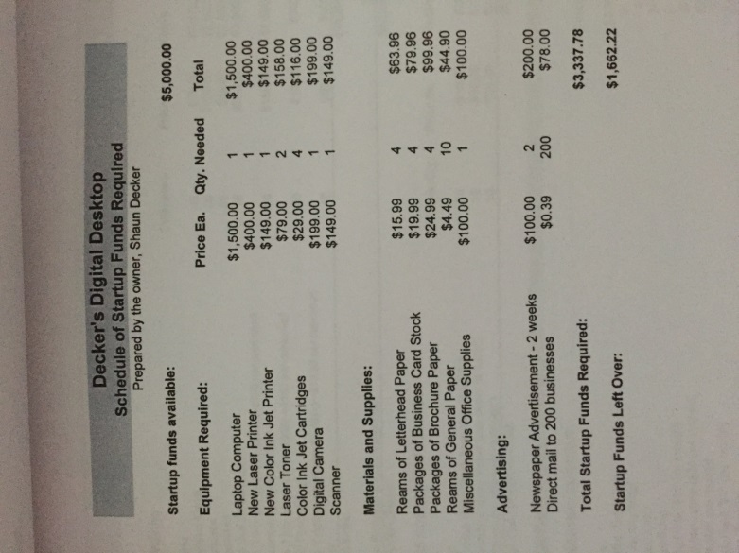
Appendix

This section should include all the attachments needed:

- Advertisements
- Pictures of your business location and products
- Business Logo
- Link to your website

