Shark Tank Episode Reflection
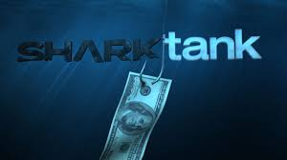

Directions:
- Watch a shark tank episode by going to YouTube, abc.com or cnbc.com
- Answer the questions listed below while watching the video. Be sure to use complete sentences and proper grammar.

Entrepreneur #1
- What business did they create?

- What is the product they developed?

- In your opinion, what are the pros/cons of their product?

- What Marketing Strategy did they use?

- Who is their competition?

- Who are their primary customers?

- Why do you think the sharks did or did not invest in their business?

- In your opinion, what are the pros/cons of their branding/marketing?
Entrepreneur #2
- What business did they create?

- What is the product they developed?

- In your opinion, what are the pros/cons of their product?

- What Marketing Strategy did they use?

- Who is their competition?

- Who are their primary customers?

- Why do you think the sharks did or did not invest in their business?

- In your opinion, what are the pros/cons of their branding/marketing?

Reflection
- Out of all the businesses, which one was your favorite?

- List 3 tips you learned from this episode that will help you in Marketing.

