A Midsummer Night’s Dream – Character Sheet

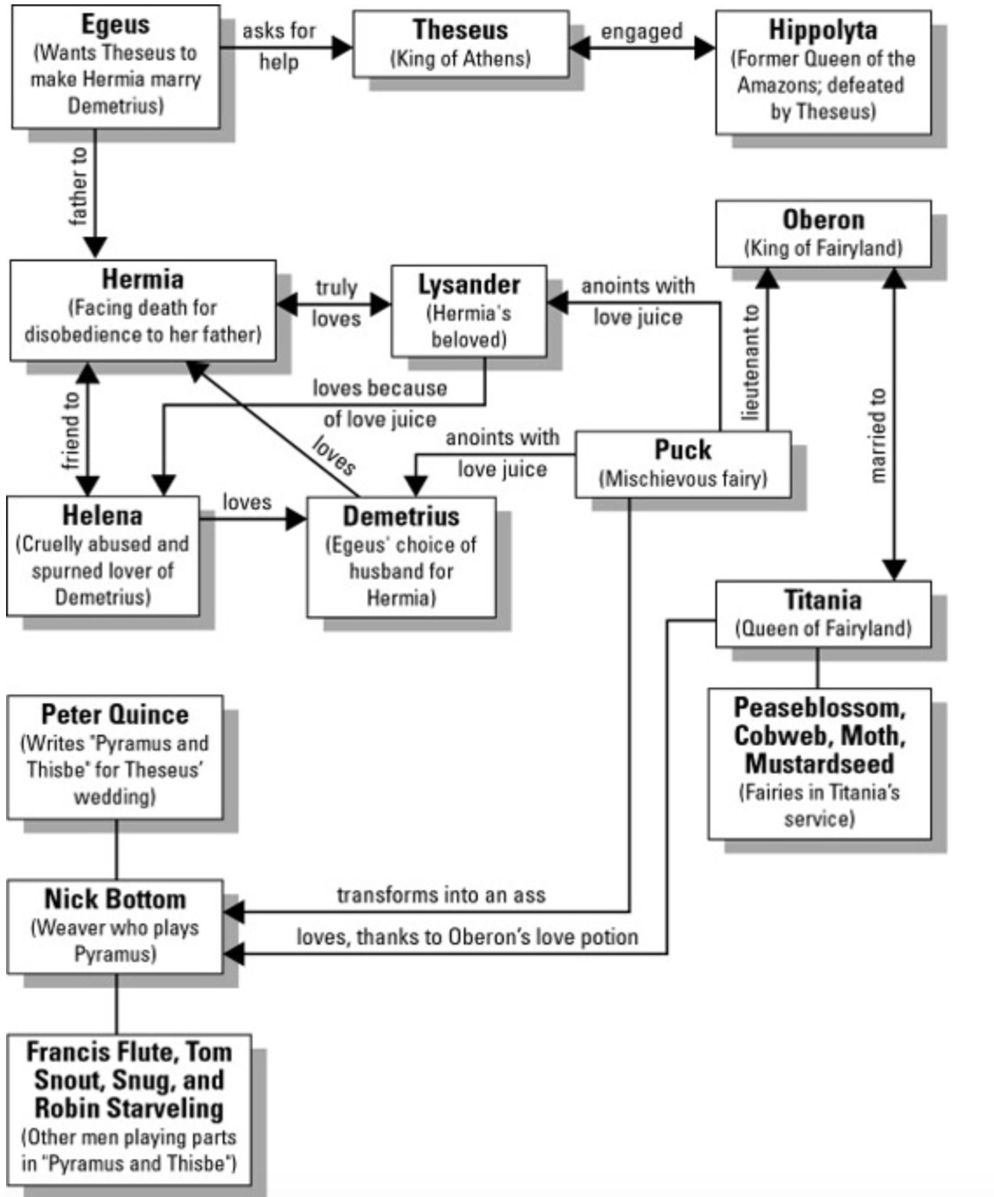

A Midsummer Night’s Dream Character Descriptions
Human Court
Theseus - Duke of Athens, recently returned from conquering the Amazons, a race of warrior women and is about to marry the conquered Amazon Queen Hippolyta.
Lysander - Young nobleman of Athens. In love with Hermia. Hermia’s father is against her marrying him, he persuades Hermia to run away from home & family into the forest.
Demetrius – A young nobleman of Athens. In the past, he acted as if he loved Helena, but after Helena fell in love with him, he changed his mind and having the approval of Egeus, he pursues Hermia. (But she’s not interested)
Egeus - An Athenian upper-class respected gentleman who wants his daughter Hermia to marry Demetrius, his choice for her.
Philostrate - Theseus’s Master of the Revels (party planner) who is responsible for organizing the entertainment for the Duke’s marriage celebration.
Hippolyta - The legendary Queen of the Amazons engaged to marry Theseus.
Hermia - Egeus’s daughter. Both Demetrius and Lysander are in love with her. She is in love with Lysander. Very strong-willed and independent.
Helena - A good friend of Hermia’s and is in love with Demetrius. She tends to be more self-pitying and puts herself in dangerous and humiliating situations, running after Demetrius through the forest even though he wants nothing to do with her.

Fairy Court
Puck – (AKA Robin Goodfellow) A mischievous fairy who delights in playing pranks on mortals; he is Oberon’s servant. He has a connection not only to the fairy and human worlds of the play, but also to the world of the audience.
Oberon - The King of the Fairies who rules with Titania
Titania - Queen of the Fairies who rules with Oberon
Changeling - young Indian prince whom Titania has kidnapped (child role)
Peasebottom, Moth, Cobweb, and Mustardseed – Fairies with a few lines,

The Mechanicals – Aspiring Thespians who provide comic relief
Nick Bottom - The overconfident weaver chosen to play Pyramus in the play that a group of craftsmen have decided to put on for the wedding celebration.
Peter Quince - A carpenter and the writer/director of the play
Francis Flute - The bellows-mender chosen to play Thisbe in the play. Forced to play a young girl in love.
Robin Starveling - The tailor, chosen to play Thisbe’s mother in the play/ends up playing the part of Moonshine
Snug - The joiner (a tradesperson who builds things by joining wood), chosen to play the lion in the play.
Tom Snout - The tinker (someone who does odd jobs) chosen to play Pyramus’s father in the play. Ends up playing the part of the Wall, dividing the two lovers in the play

