Creative Writing Unit: Final Story
This story will be the final major product of our creative writing unit. In the story you will have to utilize all the skills you have been taught. This means you should have properly written dialogue, a clear point of view, sticking to one tense, a descriptive setting, a hook paragraph, character development, proper paragraphs, plot and endings.
This story is all yours to do with what you want. You can write about anything under the sun as long as it is school appropriate, we’ll go over what that means in class. You are welcome to re-use anything we have written in class for this story, just make sure to make any improvements necessary to them before submitting the final copy.

Requirements:
- 3-6 pages long. Three is the minimum and six is the maximum.
- 12 point font Times New Roman. Please double space.
- Your story should have a title that is related to the story.
- You must attach an edited rough draft of your story to your final copy.
- You must attach the basic story arc of your story and a short character sketch of at least one character in the story.
- You can write about whatever your want as long as it is school appropriate.
- You may re-use the character you already created in class for this story. You may also re-use the hook paragraph you created.
- Please put your name and block on the story in the upper left or right hand corner.

This assignment is due at the beginning of class on December 12th, 2014. If you require extra time for this assignment, you must email me at ashley_legault14@hotmail.com but you must include the reason why you need an extension and propose an alternate date for you to turn it in. If you do not request an extension, I expect you to come to class on December 12th with your completed assignment.
Daily Writing Prompt Submission Assignment
Throughout the course of our creative writing unit, we have been doing daily writing prompts based off of random scenarios and random pieces of dialogue. You used those scenarios and lines of dialogue to create a series of short stories with the ultimate goal of creating a mini collection of prompts. It is now time to submit them.
The time has come to pick your best prompts and spruce them up so they are the best they can be. You will put them all together, give the collection a nifty title page and hand them in.

Requirements:
- You need to submit your three best writing prompts.
- You must edit them and add to them to make them even better.
- They must each be at least a page double spaced, for a minimum of three pages.
- You need to use Times New Roman font in size 12.
- Each prompt needs to have a title that is related to the prompt and is more creative than ‘Prompt #1.’
- Your collection of prompts should have a title page. On the title page you need to include your name and a title for your collection. Pretend that your collection is a short anthology and give it a creative title. Then decorate the title page!
- Include a short author’s biography at the back of the collection of prompts.

This assignment is due on December 17th, 2014. Due to the lateness in the term and my time at Elphinstone Secondary School, no extensions will be granted. Please come to class with your assignment completed on December 17th. You are welcome to turn it in early if you would like.

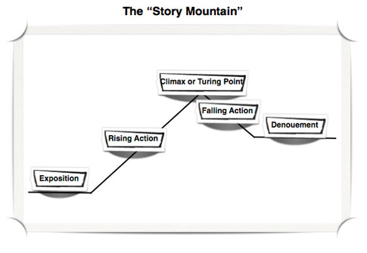

Exposition: The reader is provided with the background necessary for understanding the characters and the initial setting.
Conflict: The physical, emotional or spiritual crisis that occurs when the main character meets some opposing force.
Rising Action: The complication or intensification that occurs as a result of the conflict.
Climax: The turning point, or the point of most intense interest, in the plot.
Falling Action: The denouement, in which the author begins to describe the outcome of the conflict.
Resolution: The final outcome is described or hinted at.

