English 8 Short Story Assignment
We are finally on the short story mini unit of our Creative Writing unit. That means that the assignment of the two or so weeks where we are covering creative writing will be a short story.

In class we will practice writing characters and setting in preparation for your stories. We will also brainstorm a character as a class and come up with ideas for a plot, so if you can’t think of something on your own, you can write about the character we come up with as a class. Your story should aim to follow the exposition, rising action, climax, falling action and denouement/resolution formula.

Requirements:
- Minimum one page typed. However, I would encourage you to write more, because one page is not a lot of space to tell a story. The maximum number of pages is five.
- 12 point font in Times New Roman. Please double space.
- Must include a rough draft that has been edited along with your final copy. You can get your parent or friend to edit it for you.
- Your story should have a title. I do not want it to have a title page, but your story needs to have a title page.
- You should include two literary devices in your story (ex. Metaphor, simile, personification, etc.) They can be two different ones or two of the same one, but there needs to be two. Feel free to use more than two. Please underline them in your text for easier spotting.
- Please put your name and block on the story in the upper left or right hand corner.
This assignment is due on December 8th, 2014 for Block D1 and on December 9th, 2014 for Block D2. We will not have time to work on it in class on the due dates though we will have two in class work periods before this date for you to work on it. You must come to class with a printed copy of your assignment.
Bonus: You will receive a bonus mark on your assignment if you come with a picture of an actor or star you would cast as the main character of your story.
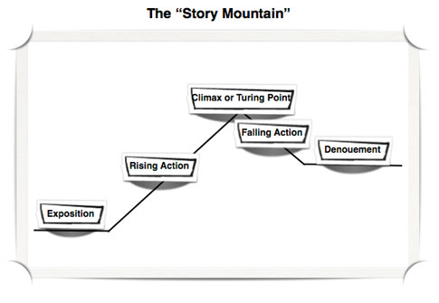
Exposition: The reader is provided with the background necessary for understanding the characters and the initial setting.
Conflict: The physical, emotional or spiritual crisis that occurs when the main character meets some opposing force.
Rising Action: The complication or intensification that occurs as a result of the conflict.
Climax: The turning point, or the point of most intense interest, in the plot.
Falling Action: The denouement, in which the author begins to describe the outcome of the conflict.
Resolution: The final outcome is described or hinted at.
Your character will be the:
Protagonist: The character whose exploits and adventures the reader is chiefly interested in following.
You want your character t be a:
Round Character: A well-described character; the reader is able to construct a complete picture of the physical and emotional qualities of the character.

