Entrepreneurship Basics
Intro to Entrepreneurship Video
Jot down some key points from the video.

What is an entrepreneur?
- Someone who exercises initiative by organizing a venture to take benefit of an opportunity and, as the decision maker, decides what, how, and how much of a good or service will be produced.
- An entrepreneur supplies risk capital as a risk taker, and monitors and controls the business activities. The entrepreneur is usually a sole proprietor, a partner, or the one who owns the majority of shares in an incorporated venture.
- They come in all ages, backgrounds, and create all different types of businesses.

What is entrepreneurship?
- Entrepreneurship focuses on recognizing a business opportunity, starting a business based on the recognized opportunity, and operating and maintaining that business.

Why do people become entrepreneurs?
There are many reasons why someone starts their own business:
      - Leave their daily job.
      - Pursue a dream.
      - Thought of a great idea.
      - Wants to run their own business with their own hours.
      - Other reasons?

Think about it…
List three reasons why you think someone would want to start their own business:
1.

2.

3.

Name three local businesses and think of the purpose why the business was created:
1.

2.

3.

Pros and Cons of Entrepreneurship:
Advantages | Disadvantages
- Your own boss  - Right to choose a business that interests you  - You can be creative  - You can make large sums of money | - Risky  - Uncertain outcomes  - Work long hours  - Make all decisions by yourself

Types of Entrepreneur Businesses
- Manufacturing - produces the products they sell.
- Wholesaling - sell products to other businesses rather than the final consumer
- Retailing - sell products directly to the people
- Service - sell services rather than products
- Green - focus on being organic or “green”.
- Social - find innovative solutions to society's most press social problems.
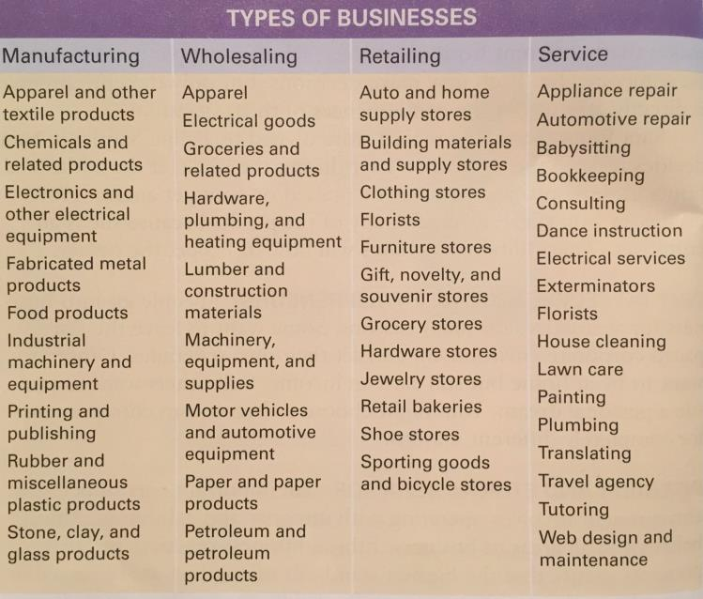
What type of business would you like to start up?
Entrepreneurs who Changed the World
- Steve Jobs- Invented Apple
- Bill Gates- Creator of Microsoft
- Henry Ford- Creator of Ford Company
- Mark Zuckerberg – invented Facebook and boosted social media.
- Name 2 more…

Characteristics of Successful Entrepreneurs
- Independent
- Self-confident
- Determination and perseverance
- Goal-oriented
- Creative
- Strong work ethic
- Master networkers
- Up to date with technology

- What characteristics do you have to make you a great entrepreneur?

Integrity and Ethical Behaviour
- This is extremely important when running a business.
- Ethical Behavior is acting in ways consistent with what society and individuals typically think are good values. Ethical behavior tends to be good for business and involves demonstrating respect for key moral principles that include honesty, fairness, equality, dignity, diversity and individual rights.
- Integrity is the quality of being honest and having strong moral principles; moral uprightness. Operate with integrity entrepreneurs behave consistently in actions, values, methods, measures, principles, expectations, and outcomes.

Characteristics of Good Team Members
Entrepreneurs realize there are other stake holders to make their business successful. Such as investors, partners, employees, suppliers, customers, etc. Good team members display the following characteristics:
- Commitment
- Competency
- Communication
- Cooperation
- Creativity

Employees vs. Entrepreneurs
Employee | Entrepreneur
Hired to work for someone else | They assume the risk.  They are directly affected by the business.

Random Facts:
- Almost half of all new businesses do not succeed.
- A thriving community can help the success of your business.
- All it takes is one good idea.
- Many entrepreneurs start out with small business that grow into large corporations.

