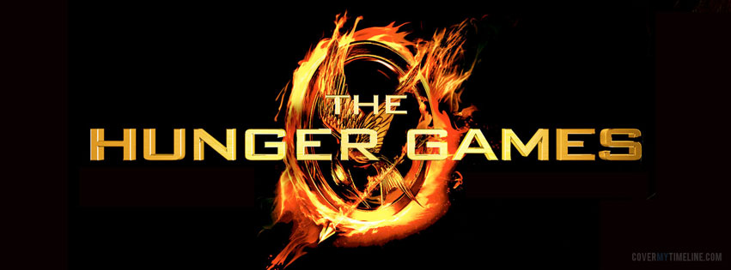

**Name: _______________________________________**

**Block: _______________________________________**

English 9 Novel Study

Unit

The Hunger Games

Themes and Essential Questions

**Theme 1: Dystopian Society**

Essential Questions:

How is Panem a Dystopian Society?

How does any ruling class maintain power?

What is my role and impact on society?

**Theme 2: Survival**

Essential Questions:

How can using individual strengths and/or intelligence help someone survive?

What is the importance of alliances to survival?

**Theme 3: Violence in Reality TV**

Essential Questions:

What is real and what is manipulation in reality TV?

How can people change perceptions in order to win?

Chapter 1

**Essential Question: How is Panem a dystopian society?**

Read each descriptor of a dystopian society and find textual evidence that supports it in *The Hunger Games*. Quote specific examples and page numbers.

**Dystopia**

A **dystopia** is a community or society, usually fictional, that is in some important way undesirable or frightening.

|  |  |  |
| --- | --- | --- |
| Pressure to Conform | Urban Setting | Isolation of Character |
| Totalitarian Government | Hero Questions Society | Backstory of War, Revolution, Destruction |

Chapter 1 Panem

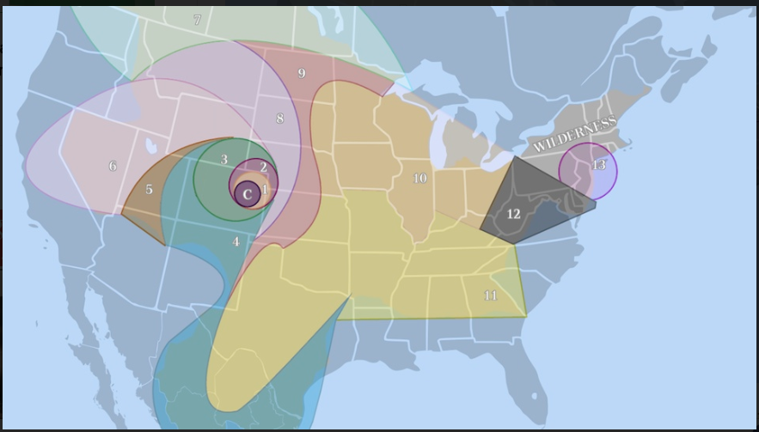

|  |  |  |
| --- | --- | --- |
| District | Industry | Tributes |
| Capitol |  |  |
| 1 |  |  |
| 2 |  |  |
| 3 |  |  |
| 4 |  |  |
| 5 |  |  |
| 6 |  |  |
| 7 |  |  |
| 8 |  |  |
| 9 |  |  |
| 10 |  |  |
| 11 |  |  |
| 12 |  |  |

Chapter 1: Personal Word Journal

Keep track of key academic vocabulary and other words of interest from the novel.

|  |  |  |
| --- | --- | --- |
| Word | Definition | Example |
|  |  |  |
|  |  |  |
|  |  |  |
|  |  |  |
|  |  |  |
|  |  |  |
|  |  |  |
|  |  |  |
|  |  |  |
|  |  |  |
|  |  |  |
|  |  |  |
|  |  |  |
|  |  |  |
|  |  |  |
|  |  |  |
|  |  |  |
|  |  |  |
|  |  |  |
|  |  |  |
|  |  |  |
|  |  |  |
|  |  |  |
|  |  |  |
|  |  |  |
|  |  |  |
|  |  |  |
|  |  |  |
|  |  |  |

**Character Notes:**

Write down what you need to know and remember about the following two characters.

|  |  |
| --- | --- |
| **Katniss** | **Peeta** |
|  |  |

Minor Characters Study Guide

|  |  |  |
| --- | --- | --- |
| Character | Characteristics | Connections and relevance to Katniss |
| Gale |  |  |
| Prim |  |  |
| Mother |  |  |
| Father |  |  |
| Madge |  |  |
| Avox |  |  |
| Haymitch |  |  |
| Cinna |  |  |
| Effie |  |  |
| Rue |  |  |
| Foxface |  |  |
| Thresh |  |  |
| Cato |  |  |
| Clove |  |  |
| Glimmer |  |  |
| Marvel |  |  |

Symbols in *The Hunger Games*

|  |  |  |  |
| --- | --- | --- | --- |
| Symbol | Occurrence | Textual Evidence | Significance |
| Mockingjay |  |  |  |
| Bow and Arrow |  |  |  |
| Fire |  |  |  |
| Dandelion |  |  |  |
| Cornucopia |  |  |  |
| Cannons |  |  |  |
| Moons |  |  |  |