How to Get to Collections:

Go to DESTINY: www.destiny.sd46.bc.ca

Click on “Chatelech Secondary School”:

Click on “Catalogue”:

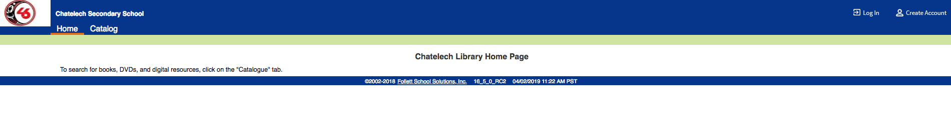

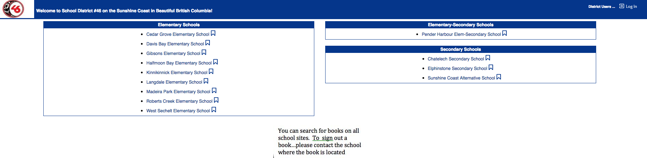
Click on “Destiny Discover”:
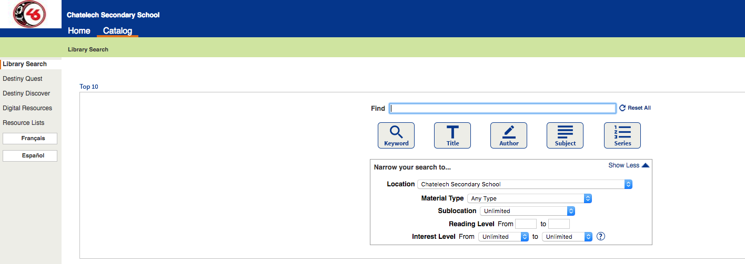

Click on the three bars on the left-hand side of the page:
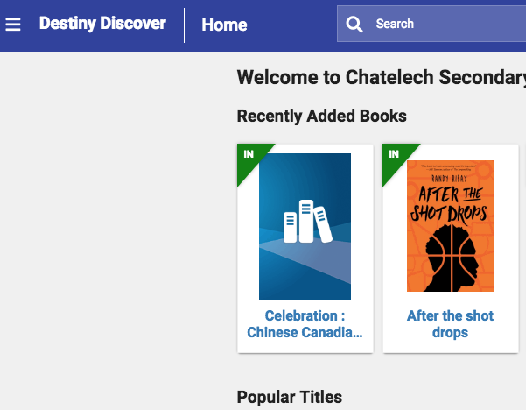
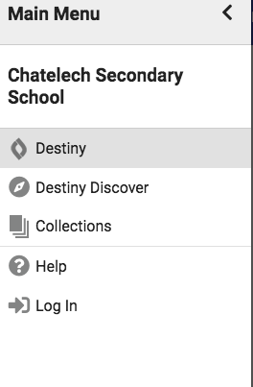

Click on “Collections”.

