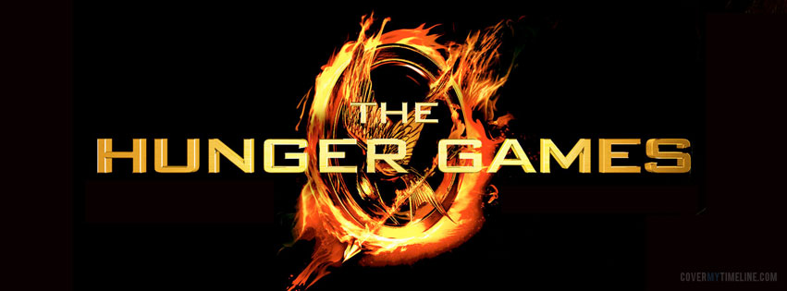
Name: _______________________________________
Block: _______________________________________
English 9 Novel Study
Unit

The Hunger Games
Themes and Essential Questions

Theme 1: Dystopian Society
Essential Questions:
How is Panem a Dystopian Society?
How does any ruling class maintain power?
What is my role and impact on society?

Theme 2: Survival
Essential Questions:
How can using individual strengths and/or intelligence help someone survive?
What is the importance of alliances to survival?

Theme 3: Violence in Reality TV
Essential Questions:
What is real and what is manipulation in reality TV?
How can people change perceptions in order to win?

Chapter 1
Essential Question: How is Panem a dystopian society?
Read each descriptor of a dystopian society and find textual evidence that supports it in The Hunger Games. Quote specific examples and page numbers.

Dystopia
A dystopia is a community or society, usually fictional, that is in some important way undesirable or frightening.
Pressure to Conform | Urban Setting | Isolation of Character
Totalitarian Government | Hero Questions Society | Backstory of War, Revolution, Destruction
Chapter 1 Panem
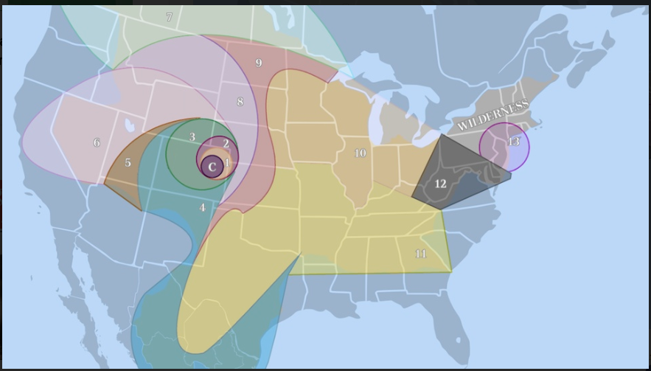
District | Industry | Tributes
Capitol
1
2
3
4
5
6
7
8
9
10
11
12
Chapter 1 Questions
- Describe District 12.

- What illegal activity does Katniss participate in? Why does she do this?

- Describe the relationship between Gale and Katniss. Why do you think the author is discussing this relationship so much at the beginning?

- What is reaping? Why do you think the Capital calls it this? Why is this ironic?

- What is Dystopian Society? Cite evidence from the text that demonstrates a feature of a dystopian society.

Chapter 1: Personal Word Journal
Keep track of key academic vocabulary and other words of interest from the novel.
Word | Definition | Example

Character Notes: Katniss Everdeen
Chapter | New Information about Katniss | Significance
1

2

3

4

5

6

7

8
9

10

11

12

13

14

15

16

17

18

19

20

21

22

23

24

25

26

27

Character Notes: Peeta Mellark
Chapter | New Information about Peeta | Significance
1

2

3

4

5

6

7

8

9

10

11

12

13

14

15

16

17

18

19

20

21

22

23

24

25

26

27

Minor Characters Study Guide
Character | Characteristics | Connections and relevance to Katniss
Gale

Prim

Mother

Father

Madge

Avox

Haymitch
Cinna

Effie

Rue

Foxface

Thresh

Cato

Clove

Glimmer

Marvel

Symbols in The Hunger Games
Symbol | Occurrence | Textual Evidence | Significance
Mockingjay

Bow and Arrow

Fire

Dandelion

Cornucopia

Cannons

Moons

Chapter 2 Questions
- How does Katniss save her sister from the reaping?

- Describe Peeta. What kind of person is Peeta so far? What evidence from the book illustrates these traits?

- What evidence in this chapter might suggest Peeta is an abused child?

Chapter 3 Questions
- What instructions does Katniss leave for her mother?

- What act of kindness does Peeta’s dad show to Katniss? How do you think this man might have influenced his son?

- Why do you think the Capital changes the location of the games?

Chapter 3
Irony= the use of words to convey the opposite of their literal meaning. (ex. It’s ironic that a large dog is named Tiny)
Imagery= descriptive writing that creates a vivid mental picture.
Word or Phrase | Irony or Imagery? Why? | How does it relate to elements of a dystopian society?
Peacekeepers (p. 34) | Irony – they are essentially military police, who are used to control and suppress people. | It is part of the control the government uses to keep the people in line.
“The station is swarming with insect-like cameras trained directly on my face.” (p. 40)

“We have to stand for a few minutes in the doorway of the train while the cameras gobble up our images, then we are allowed inside and the doors close mercifully behind us.” (p. 41)

“The peacekeepers march us through the front door of the justice building…..conducted to a room and left alone-it’s the richest place I’ve ever been in with deep rich carpets and…” (p. 34)

Chapter 4 Questions
- Do you think Haymitch will be helpful as a mentor? Why or why not?

- What does Katniss mean when she says: “A kind Peeta Mellark is far more dangerous to me than an unkind one.”?

- What happens to convince Haymitch that Peeta and Katniss might be fighters?

- “May the odds be ever in your favor.” How does Katniss’s survival skill work in her favor against a society’s quest for entertainment?

Chapter Five
Makeover for Survival?
Identify the steps in the physical makeover that Katniss goes through in the Remake Center. What do they do to get her “ready” for the games?
Steps | Evidence from Text  (Quote/Page #) | Relation to the theme of Dystopian Society or Survival? Why?
Hair Removal |  | Dystopian: They believe in a certain style of perfection.
Read each quote and tell how it relates to the theme of survival and/or Reality TV:
- “Cinna has given me a great advantage. No one will forget me. Not my look, not my name. Katniss. The girl who was on fire.” (p. 70)

- “A warning bell goes off in my head. Don’t be so stupid. Peeta is planning how to kill you, I remind myself. He is luring you in to make you easy prey. The more likeable he is, the more deadly he is. But because two can play at this game, I stand on tiptoe and kiss his cheek…” (p. 72)

Chapter Six p. 73-85
Venn Diagram: Compare and contrast life in the Capitol to life in the Districts.

Life in the Districts
Life in the Capitol

- What is an Avox?

- How does an Avox fit into Dystopian Society? What is their purpose?

- Should Katniss have intervened when the girl was taken by the hovercraft? Why or why not?

Chapter 7
Quick Writes

How do teenagers typically rebel against authority? Give examples.

Chapter 8
How has Katniss rebelled since arriving at the training center?

Has her rebellion helped or hurt her as a Tribute? Take a position and justify your response with evidence from the text.

Chapter 9: Perceptions
Respond to quotes in Chapter 9 that demonstrate Theme 3: Violence in Reality TV-Essential Question 1, as it relates to the idea of how people try to change perceptions about themselves in order to win:
Evidence from the Text | How this represents Theme 3
“Just remember, Katniss, you want the audience to like you…”  “They’re betting on how long I’ll live!” I burst out. “They’re not my friends!”  “Well try and pretend!” snaps Effie. Then she composes herself and beams ar me. “See, like this…” (p. 115) | Effie is trying to make Katniss act differently so that she appears more likeable. Effie is so used to being fake and playing the game that the Capitol forces people to play in order to survive, that she doesn’t even think twice about it. Pretending is second nature to her now.
“I’m trying to figure out what to do with you,” he says. “How we’re going to present you. Are you going to be charming? Aloof? Fierce… The impression you make tomorrow will decide what I can get you in terms of sponsors,” says Haymitch. (p. 116)

Chapters 5-9
Respond in paragraph form to one of the two questions.

- How is Panem a Dystopian Society so far? Describe how it looks, how it’s citizen act, what they value and how they control the districts.
- What survival skills does Katniss have? Describe her specific skill set in both intelligence and physical abilities.

______________________________________________________________________________
______________________________________________________________________________
______________________________________________________________________________
______________________________________________________________________________
______________________________________________________________________________
______________________________________________________________________________
______________________________________________________________________________
______________________________________________________________________________
______________________________________________________________________________
______________________________________________________________________________
______________________________________________________________________________
______________________________________________________________________________
______________________________________________________________________________
______________________________________________________________________________
______________________________________________________________________________
______________________________________________________________________________
______________________________________________________________________________
______________________________________________________________________________
______________________________________________________________________________
Chapter 10
Quickwrite:
3 Things I know about a Dystopian Society | 3 Questions I have about a Dystopian Society

Page 144 refers to the Launch Room as a stockyard, which is where animals go before they are slaughtered. How is this reference appropriate at this point of the book?

In a dystopian society there is pressure to conform. Peeta doesn’t want the Capitol to change him into a monster during the games. Is this a form of rebellion? Do people have to turn into a monster when they change?

Chapter 11
Identify events from the novel that connect to any of the themes. Note the page number, synthesize or summarize the event and explain how it connects to a theme.
Page Number | Event | Connection to Theme
152 | Day 1 is one of the heaviest betting days of the games. | Violence in Reality TV: There will be many deaths on the first day, which would be food for viewers and ratings. After the first day and the group is thinned down, the betting odds will get closer together.
155-156 | Katniss describes picking a good tree, climbing it, and securing herself.
156 | The author describes the end of the day with the anthem and the death recap.

Chapter 11
How does the author indicate how time is passing by?
Is the passing of time realistic or is it a manipulation of time by the Gamemakers?

Quote and Page Number | Realistic or Manipulation (How do you know?)

What does the following quote tell us about Katniss?
“Maybe it’s better, if he’s gone already. He had no confidence he could win. And I will not end up with the unpleasant task of killing him. Maybe it’s better if he’s out of this for good.”

Quick Write: How do alliances aid in survival? Do you believe Peeta is really in love with Katniss or is it a strategy?

Chapter 12
Why is Peeta traveling with the Careers? Is it a real alliance or a manipulation on his part?

How does Katniss stack up as a tribute in relation to the Careers? In what ways is she better than they are?

List the skills Katniss uses for survival. Describe how each skill benefits her.
Skill Katniss uses for survival | How they are a benefit to her

How might the reference to the berries be a foreshadow to events yet to happen?

Chapter 13
In Chapter 13, there are many examples of manipulation from the Tributes and the Capitol. Find examples in the text and complete the chart. The first one is done for you.
Example in Text | Who is manipulating whom, and for what reason?
This was no tribute’s campfire gone out of control, no accidental occurrence. The flames that bear down on me have an unnatural height, a uniformity that marks them as human-made, machine-made, Gamemaker-made. | The Gamemakers are manipulating Katniss and the other tributes. The purpose for this manipulation is to get the tributes out of hiding and to make the Games more exciting for the viewers.

Chapter 10-14: Assessment
Selected Response
- Haymitch believes the key to survival in the arena is to find what first?
  - The bow and arrow
  - Water
  - Fire
  - Food
- Peeta’s strategy for getting sponsors is to
  - Make himself a lovesick boy
  - Ally himself with the tributes
  - Hide until it’s over
  - Beg for help
- Which of the following did Katniss not get in her backpack of supplies?
  - Water jug
  - Iodine pills
  - Bow and arrow
  - Sleeping bag
- The gamemakers send the fire balls to
  - Force the tributes together
  - Entertain themselves
  - Remind the tributes they can kill them
  - All of the above
- Katniss escapes the Careers by
  - Getting in a hovercraft
  - Setting in the trackerjacker nest on them
  - Shooting them with arrows
  - Hiding in the mud

Describe Katniss’ skills as a Tribute so far. What does she know how to do and how has it helped her?

Is Peeta Katniss’s enemy or ally? Why? Give at least 3 specific examples. Justify your responses with evidence from the text.

Choose one theme (Dystopian Society, Survival or Violence in Reality TV) and describe how it is playing out in the story so far. Give evidence from the text.

Chapter 15
List the skills and benefits that Rue and Katniss bring to each other as allies.
Rue Katniss
Skills | How it helps Katniss | Skills | How it helps Rue

Is it always better to have an ally? Why or why not?

What is District Eleven’s industry?

How is it controlled by the Capitol?

Why is this ironic?

Do you think the Capitol is censoring Rue and Katniss’s conversation? Why or Why not?
Chapter 16
During the games Katniss was often on the defensive from the other tributes. She and Rue have now decided to become more offensive in their strategy. Complete the chart showing what events in Chapter 16, illustrate an offensive strategy. Go back into other chapters to find events to illustrate a defensive strategy.
Defensive Strategy | Offensive Strategy
p. 155: Katniss finds a sturdy tree to climb in order to spend the night out of sight of the others. | p. 288: Katniss begins to think of a plan to destroy the Careers food supply rather than to continue to hide and run away.

How will the Careers be at a disadvantage?

How do things change when you are put on the defensive?

Chapter 17-18
Quote | Theme Connection | Significance
“The betting must be getting really hot in the Capitol. They’ll be doing special features on each of us now. Probably interviewing our friends and families.” (p. 226)

“It crosses my mind to reveal myself and enlist her (Foxface) as a second ally against that pack. But I rule it out. There’s something about that sly grin that makes me sure that befriending Foxface would ultimately get me a knife in the back.” (p. 227)

“I want to do something right here, right now, to shame them, to make them accountable, to show the Capitol that whatever they do or force us to do, there is a part of every tribute they can’t own. That Rue was more than a piece in their Games. And so am I.” (p. 236-237)

“This bread came from District 11…what must it have cost the people of District 11 who can’t even feed themselves?...for whatever reason, this is a first. A district gift to a tribute who is not your own.” (p. 239)

Chapter 19
Why does Katniss scream Peeta’s name at the end of Chapter 18?

Find evidence in the text to support each of the following claims regarding the relationship between Katniss and Peeta.
The Relationship is Real | The Relationship is for the Cameras
Final Conclusion:

Chapter 15-19
Answer one of the following questions in paragraph form.
- How has Katniss’s character developed up to this point in the novel? What have you learned about her? In what ways is she both a survivor and a nurturer?
- Now many tributes are left in the Games. How Has the Capitol influenced the Games? List some specific examples that illustrate their influence.
- Given the rules and nature of the Games, how do alliances both benefit and burden the Tributes?

______________________________________________________________________________
______________________________________________________________________________
______________________________________________________________________________
______________________________________________________________________________
______________________________________________________________________________
______________________________________________________________________________
______________________________________________________________________________
______________________________________________________________________________
______________________________________________________________________________
______________________________________________________________________________
______________________________________________________________________________
______________________________________________________________________________
______________________________________________________________________________
______________________________________________________________________________
______________________________________________________________________________
______________________________________________________________________________
______________________________________________________________________________
______________________________________________________________________________
______________________________________________________________________________

Chapter 20
Is lying always wrong? Is it ever okay to lie to someone? Explain your response.

Theme 3: Violence in Reality TV
Essential Questions:
What is real and what is manipulation in reality TV?
How can people change perceptions in order to win?

Directions: Look for ways in which either Katniss, Peeta, or the Capitol uses the TV cameras to manipulate a situation. What happens and what do they hope to gain?
Which character? | How they use the TV cameras to manipulate: | What they hope to gain:
Chapter 21 p. 278-289
Theme 2: Survival
Essential Questions:
How can using individual strengths and/or intelligence help someone survive?
What is the importance of alliances to survival?

Directions: Explain the significance of each quote as it relates to survival.
Quote | Significance
“Conflicting emotions cross Thresh’s face. He lowers the rock and points at me, almost accusingly. ‘Just one time, I let you go. For the little girl. You and me, we’re even then. No more owed. You understand?” (p. 288)

“I nod because I do understand. About owing. About hating it. I understand that if Thresh wins, he’ll have to go back and face a district that has already broken the rules to thank me, and he is break the rules to thank me, too.” (p. 288)

“The last thing I remember is an exquisitely beautiful silver and green moth landing on the curve or my wrist.” (p. 289)

*Go back to the minor characters graphic organizer. Complete any new information that you have learned about Clove, Thresh and Foxface in this chapter.

Chapter 23 p. 303-319
Theme 3: Dystopian Society, Survival, Violence in Reality TV
Directions: Read and answer each question. Quote evidence from the text to support your answers and indicate which theme it relates to.
Question | Answer | Evidence | Theme
How do Peeta and Katniss think Haymitch won the games in his year?

Why does Katniss call Thresh’s death “murder?”

Why doesn’t Katniss what to marry or have children?

Why is Peeta a terrible hunter?

Who killed Foxface? How?

Chapter 24 p. 320-330
Directions: As you read Chapter 24, answer the following questions. Write the page number where you can justify response.

- Why does Katniss kiss Peeta’s forehead as he drops off to sleep? (page ____)

- Why does Katniss believe that the end of the Games is near? (page ____)

- How does the Capitol force the remaining players together? (page ____)

- Why doesn’t Cato attack Katniss and Peeta? (page ____)

Chapter 20-24
Demonstrate general understanding of the story. Select the correct response to each question:
- Peeta’s blood poisoning is cured by
  - Broth
  - Chewed up mint leaves
  - Medicine from Haymitch
- Katniss thinks the audience wants to see
  - She and Peeta in a fight
  - She and Peeta in love
  - She and Peeta dead
- Thresh does not kill Katniss because
  - She is beautiful
  - She tried to protect Rue
  - She loves Peeta
- Katniss knows that is she is to get more sponsor gifts she must
  - Win at all cost
  - Leave Peeta for Thresh
  - Play up the romance with Peeta
- Foxface is killed by
  - Thresh
  - Peeta
  - Clove

Write a brief answer to each question.
- What is the happy memory that Katniss shares with Peeta in the cave?

- Why must Katniss put Peeta to sleep to go to the Cornucopia?

- Why is Peeta a terrible hunter?

Chapter 25 p. 331-345
Describe the features of muttations:
Physical Appearance | Behaviour | Human Qualities

Answer each question and relate it to the appropriate theme:
Question | Answer | Theme Connection
Why does the Capitol send in the muttations?

Why does the Capitol allow Cato to suffer all night?

How does the Capitol try to change the outcome of the Games?

Chapter 26 p. 346-359
Which theme is most important in this novel? (Dystopian Societies, Survival, or Violence in Reality TV) Why?

After reading Chapter 26, Fill in the missing information:
Quote | Theme Connections | Explanation
“I startle when I catch someone staring at me from only a few inches away and then realize it’s my own face reflecting back in the glass. Wild eyes, hollow cheeks, my hair in a tangled mat. Rabid, feral, mad.” p. 348 | Survival: she has made it through alive  Dystopian Society: they have made her into this which she barely recognizes | Katniss barely recognizes herself. She has been reduced to almost an animalistic state by her ordeal.
“There’s usually a lag of a few days between the end of the competition and the presentation of the victor so that they can put the starving, wounded, mess of a person back together.” p. 350

“…They’re rattling on about the games, it’s all about where they were or what they were doing or how they felt when a specific event occurred…everything is about them, not the dying boys and girls in the arena.”
p. 354

“I look, very simply, like a girl. A young one. Fourteen at most. Innocent. Harmless… This is a very calculated look. Nothing Cinna designs is arbitrary.”
p. 355

 | Dystopian Society: the Capitol likes to be in control | Katniss is in danger because she tried to exert her own will and made the Capitol look bad. Now they have to try and save face in front of the country.

Will Katniss ever really be safe in Panem? Why or why not? Explain.

Chapter 27 p. 368-374
- Who is the real winner of the Hunger Games? Is it the tributes from District 12 or the Capitol? Cite the evidence to support each claim and then write a paragraph, making a decision as to who won and why.
Katniss and Peeta | The Capitol
The real winner of the Hunger Games is….

- Is it possible for Peeta and Katniss to have a future together? Why or why not?

- Why do you think the author chose to have the ending different from a typical “happily ever after” ending? How does it relate to the events and themes in the rest of the story?

