Leads Name: ____________________________

Hard news leads include all (or most) of the answers to who, what, when, where, why, and how.
Mark up the leads:
Underline who squiggle underline what circle when

box where *star why* #hashtag how#
- The Quiz Bowl Team when on Dec. 12 to compete with five high schools in the state and to reclaim the trophy they lost in a disappointing match last year.

- Poor children in the U.S. are often unprepared for school and do not learn basic reading skills in the first three grades, according to a report published last week by the Department of Education.

- Detroit – Lucky for Kai Xu, the 51 reptiles he allegedly strapped to his groin and legs during a failed border crossing weren’t snapping turtles.

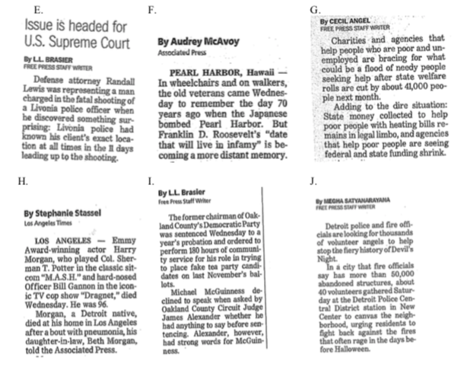
- CHICAGO (Reuters) – U.S. Scientists have developed a strain of green glowing cats with cells that resist infection from a virus that causes feline AIDS, a finding that may help prevent the disease in cats and advance AIDS research in people.
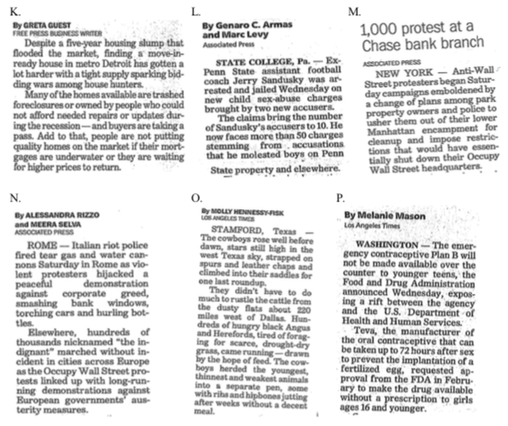
Evaluating Leads – Mark up the leads, using the method above, and then list the questions that are unanswered in each.
Q. Three graduating students win scholarships.

R. Homer High School’s all-state center, Damell McGee, has accepted a scholarship to play at State University, where he is expected to have a good chance to start as a freshman under Coach Walter Hughes’s plan to let as many freshman as he can see action early in their careers.

S. “Serving on the Student Council gives you a chance to serve the school in a very important way.”

T. What happens to Jericho High School’s seniors after they graduate?

U. Librarian Peggy Freeman said this week that 246 books are missing from Norridge High School libraries.

V. A Students Against Drunk Driving chapter has been formed at Luther Central High School.

