Unit 7 – Marketing, Promoting, and Selling Your Business

What is marketing?
- Marketing is a form of communication between you and your customers with the goal of selling your product or service to them. Communicating the value of your product or service is a key aspect of marketing.
- It deals with planning, pricing, promoting, distributing, and selling products, a service or a business.
- Using primary and secondary research (learned from last unit) can help you understand your target market, and this will help you make a marketing plan.

The Marketing Strategy
- Once you have identified your goals for your business, it’s key to develop a marketing strategy.
- Your strategy should include the following:
  - Product introduction
  - Pricing
  - Distribution
  - Promotion
  - Sales or Market share
  - Projected Profitability

Marketing Mix
- Marketing Mix is a combination of factors that can be controlled by a company to influence consumers to purchase its products.
- Marketing Mix is a blending the for ‘Marketing P’s’ which are the product, price, place, and promotion used to reach a target market.

Marketing Concept
- The marketing concept is the philosophy that businesses should analyze the needs of their customers and then make decisions to satisfy those needs, better than the competition.
- Marketing Concept uses the needs of customers as the primary focus during the planning, producing, distribution, and promotion of a product or service.

Think about it…
Why is marketing important for a business?

Goals
- When you have a marketing plan, it is smart to set goals for your business.
- Short Term Goals:
  - Within the next year
    - Example: You want your business to have a store in a key area.
- Medium-Term Goals
  - Next 2-5 years
    - Example: You would like to grow your sales and business with more employees.
- Long Term Goals-
  - 5 years- FOREVER
    - Example: You want your business to still offer the same services. Maybe open up multiple stores in other locations.

Writing Your Marketing Plan
- The marketing plan is a step-by-step guide for your company's success. It's more important than a vision statement. To put together a genuine marketing plan, you have to assess your company from top to bottom and make sure all the pieces are working together in the best way.
  - https://www.entrepreneur.com/article/43018
- Answer the following questions on your business plan:
  - What product or service will I offer?
  - Who are my prospective customers?
  - Is there a demand for this?
  - How many competitors are competition?
  - Can I create a demand for the product or serivce?
  - Can I compete in price, quality, and delivery of my product?

Product Management
- You also need an appealing look for your product or service. Consider the following:
  - Product features- color, size, delivery, warranty, etc.
  - Branding, Packaging, and Labeling- name, symbol, design.
  - Position Your Products or Services- creating an image of the product in your customers mind.

Think About It…
Think about BMW cars. What is their product management?

Pricing
- You must set price objectives for your business. You need to be able to make a profit. Consider:
  - Maximize sales
  - Increase profits
  - Discourage competition
  - Attract customers
  - Establish an image

Determining a Price
- Demand Pricing
  - How much are customers willing to pay?
- Cost-Based Pricing
  - Using the wholesale cost of an item as the basis for the price charged.
- Mark Up Example: Selling Apples
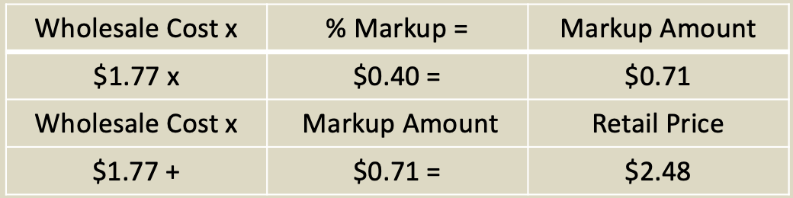

Pricing
- Competitive Based Pricing- pricing that is determined by considering what competitors charge for the same product or service.
- Time-Based Pricing- can be determined by the time it takes to complete the service.
- Bundling- when customer for all services then just one.
- Pricing an Idea- When you consult for people, you can charge what you choose.

Distribution
- Distribution is the process of making a product or service available for the consumer or business user that needs it. This can be done directly by the producer or service provider, or using indirect channels with intermediaries.
- Channel Options:
  - Manufacturer to Consumer
  - Manufacturer to Retailer to Consumer
  - Manufacturer to Wholesaler to Retailer to Consumer
  - Manufacturer to Agent to Wholesaler to Retailer to Consumer

Physical Distribution
- Physical Distribution includes all the activities associated with the supply of finished product at every step, from the production line to the consumers. Important physical distribution functions include customer service, order processing, inventory control, transportation and logistics, and packaging and materials.
- You need to consider all of the following with your business:
  - Transportation
  - Product Storage and Handling
  - Packaging
  - Receiving Goods to Sell

Advertising
- No matter how wonderful your business is, no one will know about it without advertising.
- Use some of the following for advertising options:
  - Online – Display, Ads, Email, Search Engine, Social Media
  - Television
  - Radio
  - Newspaper
  - sales
  - Direct Mail
  - Magazine
  - Outdoor
  - Transit
  - Visual
  - Telemarketing

Selling
- Selling is a very important skill to have as an entrepreneur. You will be selling your idea to investors, and hopefully customers.
- Personal selling is a direct communication between a prospective buyer and sales representative to influence the buyer to purchase an item.
- Other skills needed for selling:
  - Product knowledge
  - Determining customer needs and wants

