MPAA Rating System Name: ________________________
The Hays Commission and Crime
In 1930, the Motion Picture Producers and Distributors of America (MPPDA) led by Will H. Hays adopted a set of standards for movies. The MPPDA believed the “motion picture, because of its importance as entertainment and because of the trust placed in it by the peoples of the world, has special moral obligations.” The so-called Hays Production Code was designed to encourage good morals among moviegoers and discourage bad morals. These standards included guidelines for things that were encouraged to be shown in movies, such as respectful presentations of the U.S. flag. The standards also included guidelines for things that were discouraged. For example, movies that told stories about crime and criminals were not allowed to:
A. teach methods of crime
B. inspire potential criminals with a desire for imitation C. make criminals seem heroic and justified.
As a result, movie studios avoided making films that showed how complicated crimes, such as safecracking, were planned and committed. Criminals were usually shown as unlikable people. And, of course, the message of crime movies was always “crime doesn’t pay.”
The Hays Production Code remained in use in Hollywood until the 1960s.
In 1968, the Motion Picture Association of America (MPAA) introduced a new rating system that replaced what remained of the old Hays Code. Over the years, there have been several changes and additions to the MPAA rating system. Here is the rating system as it stands today, with a brief description by the MPAA of what each rating means.
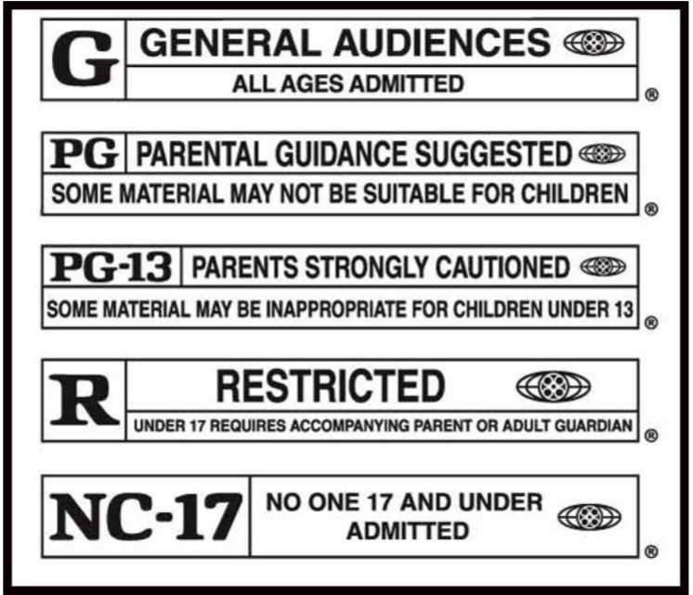
G: General Audiences. All Ages Admitted.
A film that contains nothing in theme, language, nudity and sex, violence, and so forth which would, in the view of the Rating Board, be offensive to parents whose younger children view the film. The G rating is not a “certificate of approval,” nor does it signify a children’s film.
PG: Parental Guidance Suggested. Some Material May Not Be Suitable for Children.
A film that clearly needs to be examined or looked into by parents before they let their children attend. The label PG plainly states parents may consider some material unsuitable for their children, but the parent must make the decision. The theme of a PG-rated film may itself call for parental guidance. There may be some profanity in these films. There may be some violence or brief nudity. But these elements are not deemed so intense as to require parents be strongly cautioned beyond the suggestion of parental guidance. There is no drug use content in a PG- rated film.
PG-13: Parents Strongly Cautioned. Some Material May Be Inappropriate for Children Under 13. A film, in the view of the Rating Board, leaps beyond the boundaries of the PG rating in theme, violence, nudity, sensuality, language, or other contents, but does not quite fit within the restricted R category. If nudity is sexually oriented, the film will generally not be found in the PG-13 category. If violence is too rough or persistent, the film goes into the R (restricted) rating. A film’s single use of one of the harsher sexually derived words, though only as an expletive, shall initially require the Rating Board to issue that film at least a PG-13 rating. More than one such expletive must lead the Rating Board to issue a film an R rating, as must even one of these words used in a sexual context.
R: Restricted. Under 17 Requires Accompanying Parent or Adult Guardian.
An R-rated film may include hard language, or tough violence, or nudity within sensual scenes, or drug abuse or other elements, or a combination of some of the above, so that parents are counseled, in advanced, to take this advisory rating very seriously. Parents must find out more about an R-rated movie before they allow their teenagers to view it.
NC-17: No One 17 And Under Admitted.
A film the Rating Board believes most parents will consider patently too adult for their youngsters under 17. No children will be admitted. NC-17 does not necessarily mean “obscene or pornographic” in the oft-accepted or legal meaning of those words. The reasons for the application of an NC-17 rating can be violence or sex or aberrant (not normal) behavior or drug abuse or any other elements which, when present, most parents would consider too strong and therefore off-limits for viewing by their children.
In 2001, the MPAA gave 30 movies a G rating, 55 movies a PG rating, 163 movies a PG-13 rating, 490 movies an R rating, and 1 movie an NC-17 rating.

