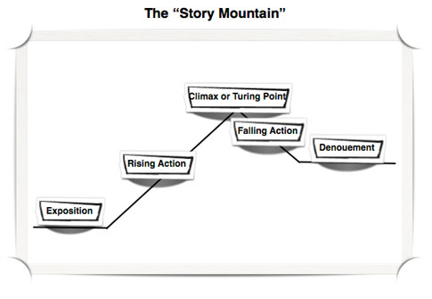
Conflict
Exposition: The reader is provided with the background necessary for understanding the characters and the initial setting.
Conflict: The physical, emotional or spiritual crisis that occurs when the main character meets some opposing force.
Rising Action: The complication or intensification that occurs as a result of the conflict.
Climax: The turning point, or the point of most intense interest, in the plot.
Falling Action: The denouement, in which the author begins to describe the outcome of the conflict.
Resolution: The final outcome is described or hinted at.

