November 24th, 2014
Introduction to the English Revolution
What is democracy?
Democracy is a _______________________ system where the government is controlled by the ____________________ who live under it.
This means that we __________________ in order to choose who our leaders will be.
The Slow Road
Democracy and civil rights do not exist in all parts of the world and they have been earned with lots of _____________________.
______________: The Magna Carta was signed. This was a huge landmark on the road to democracy.
The Magna Carta recognized individual ___________________, required a king to consult parliament and to rule lawfully.
Parliament
Parliament had been consulted in England since _________________-Saxon times. (8th-11th Centuries)
Its role was to advise the king on _________________.
The ___________________ tended to accept this democratic tradition. Tudor was the last name of Henry VIII and his children (Mary, ______________, and Edward).
The _____________________ did not. This is the key point of our introduction to the revolution. The ___________________ did not adhere to the these same democratic traditions. The _______________ took over after the Tudors in 1603 when Elizabeth I died.

The Regions of Great Britain
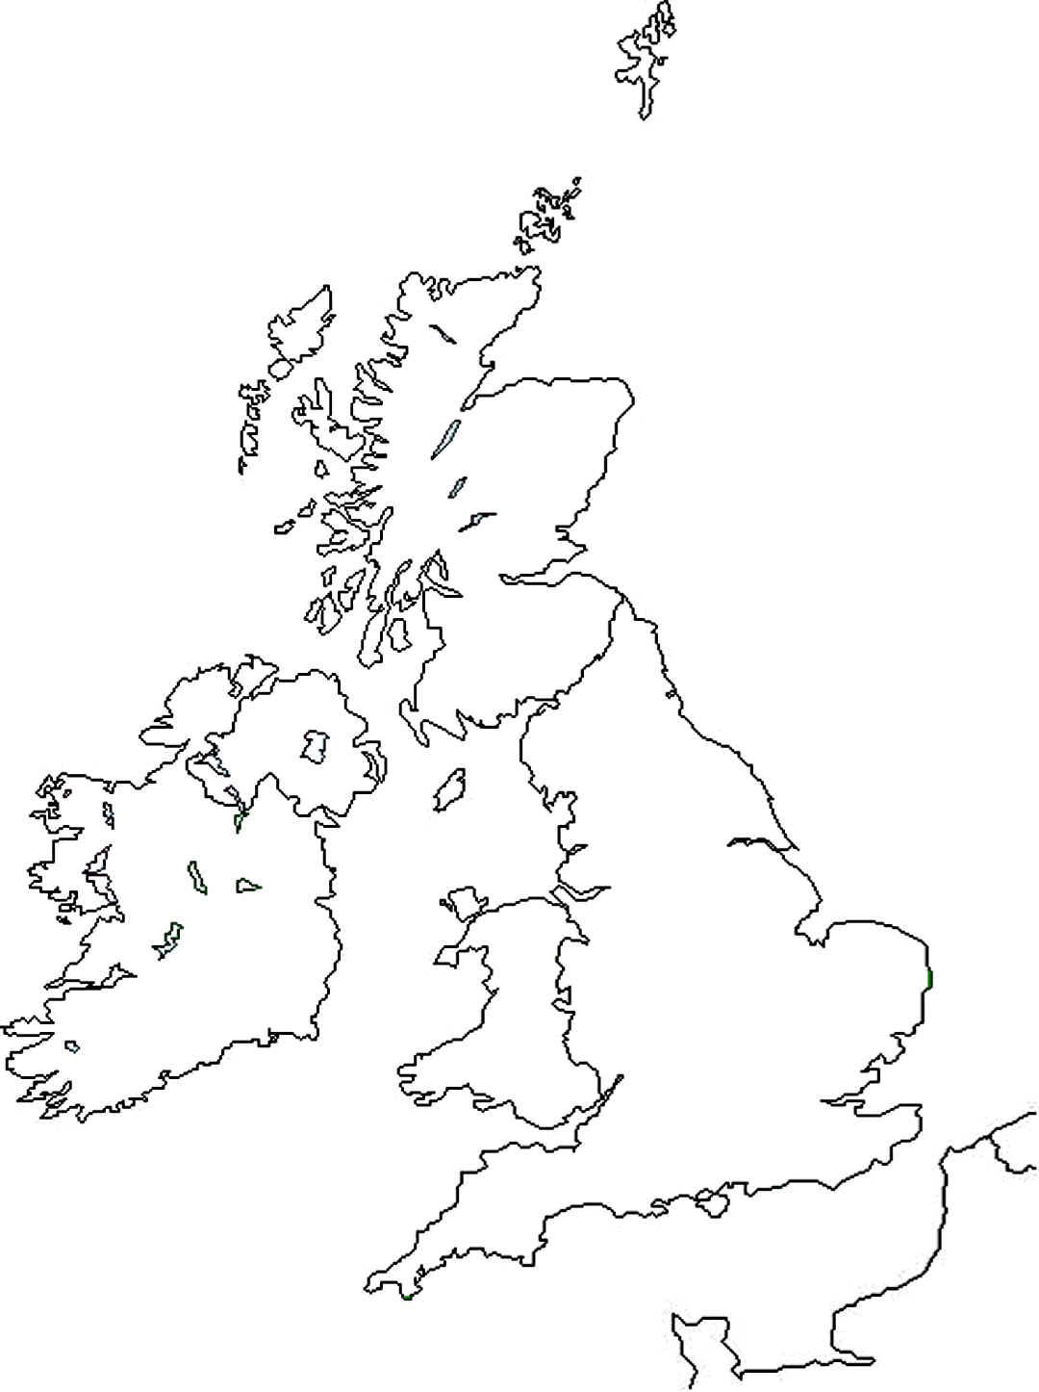
The Regions of Great Britain continued
Today Great Britain consists of England, ____________________, Wales (all on one island) and Northern _______________________.
It is separated from continental ___________________ by the English Channel.
Great Britain has _______________ kilometers of coastline. It is very much an island nation.
______________land Britain (south and east) is fertile and low lying. It is good for agriculture.
____________land Britain (north and west) is hilly and mountainous with the occasional pocket of fertile lowland.
Which area do you think is more heavily populated? ___________________
Would that make it more or less politically important? __________________
English Society
________________: The English defeated the Spanish Armada, allowing English ships to travel all over.
English became a colonizer, establishing colonies all over the world and ________________ networks along with that.
What is the name of one place they established a colony? ____________________
17th Century: English ________________ grew. Business and agriculture grew too.
There were more and more opportunities for merchants, land owners and manufacturers to become ________________________.
It was a good time for the upper class, but English society was becoming increasingly divided by deep differences between the classes.

The Three Classes
Upper: King, king’s advisors, the ______________, and high church officials (eg. Bishops)
Middle: Merchants, manufacturers, landowners, professionals, and military __________________.
Lower: Thousands of ordinary workers, peasants, farmers, etc.
Middle class aspired to move up, and occasionally could. The lower class __________________________________.
Upper and Middle Class Lives
-Those in the ___________________ and middle classes lived in nice country and town homes. They had expensive possessions, sometimes owning china from Asia and furniture from ____________________.
Why were they able to have these things? ____________________
Workers with valuable skills like carpentry and blacksmiths could afford to live very comfortably and often belonged to ______________________.
Lower Class Lives
-Workers had long hours with minimal pay. Men could make ________________ pennies a day, and women even less.
-Families often lived cramped into one or two rooms.
-They lived in deep poverty but there were no chances for them to move up and change their circumstances.
-There were many unemployed people who could only get by ________________ such as _________________, etc.
Food
Lower Class: Bread and _________________, occasionally meat and cheese.
Wealthy: Lots and lots of _______________, strongly flavoured to hide its lack of freshness.
Fruit and vegetables weren’t popular but were usually eaten _________________
They ate with spoons and knives as ________________________ were only becoming popular.
Trade brought pineapples, maize, potatoes, coffee, _____________ and chocolate.
Men began to hang out in ____________________ houses. They would drink coffee and smoke tobacco and gossip or talk politics.
The _____________________ skin hat became a popular new style.

