The Gods and Goddesses of Ancient Greece

Mount Olympus
What is it?

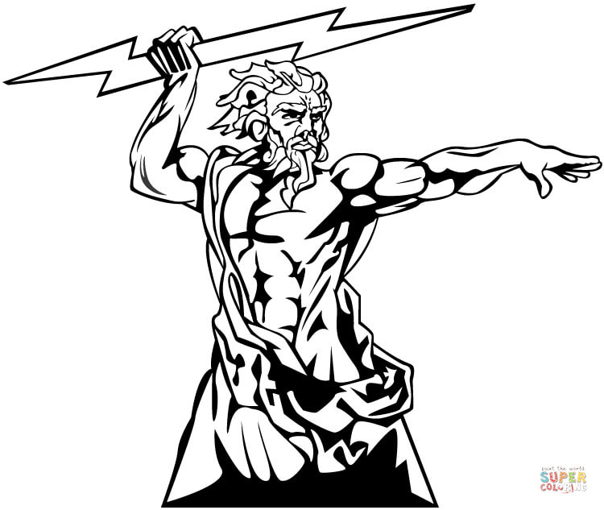
Zeus
Roman Name:

God of:

Parents:

Spouse:

One Fact:

Hera
Roman Name:

Goddess of:

Parents:

Spouse:

One Fact:

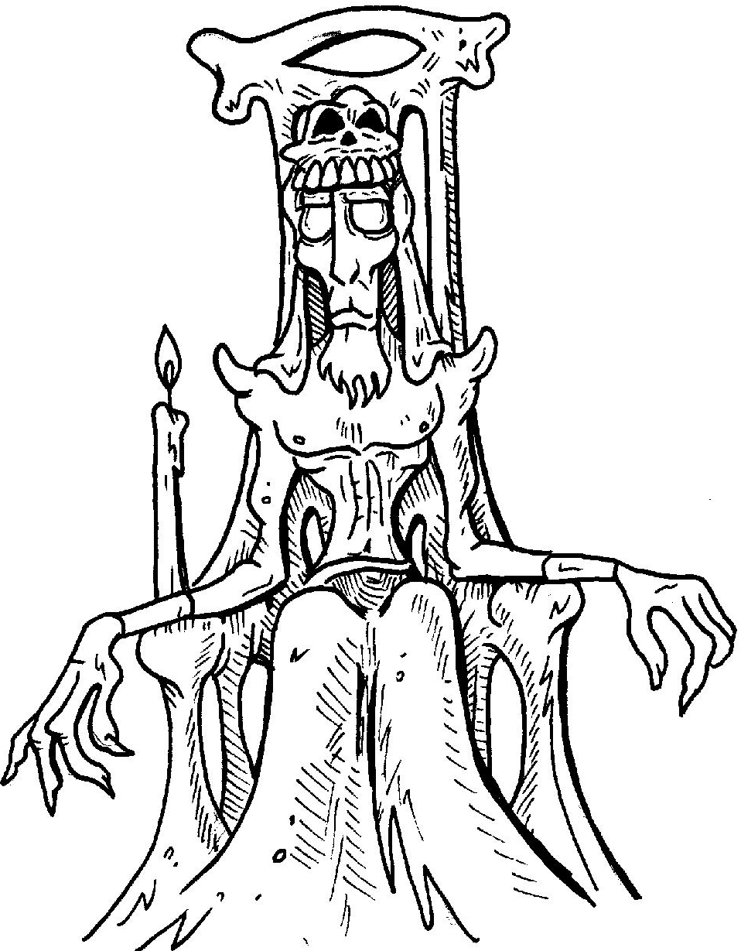
Hades
Roman Name:

God of:

Parents:

Spouse:

One Fact:

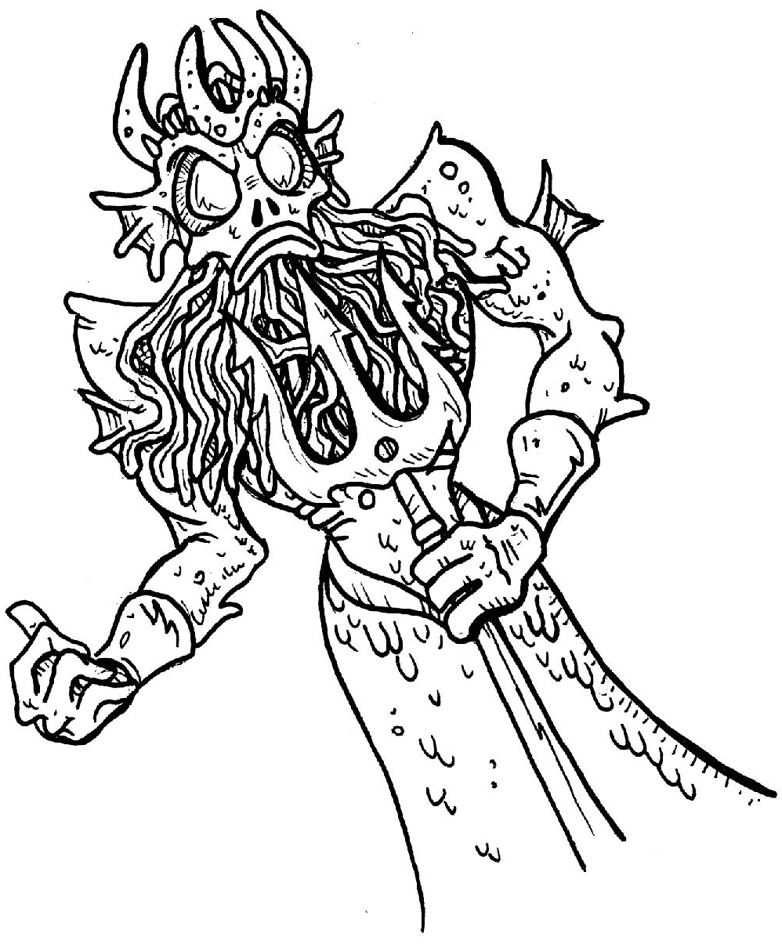
Poseidon
Roman Name:

God of:

Parents:

Spouse:

One Fact:

Demeter
Roman Name:

Goddess of:

Parents:

Spouse:

One Fact:
Aphrodite
Roman Name:

Goddess of:

Spouse:

One Fact:

Hestia
Roman Name:

Goddess of:

Parents:

One Fact:

Ares
Roman Name:

God of:

Parents:

One Fact:

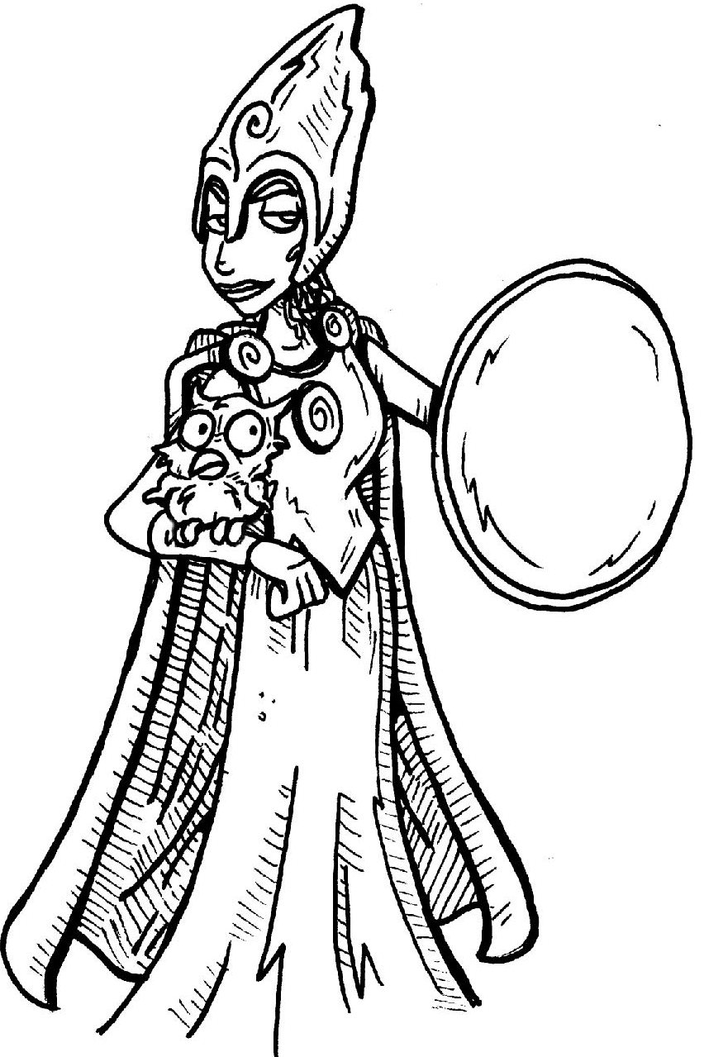
Athena
Roman Name:

Goddess of:

Parents:

One Fact:

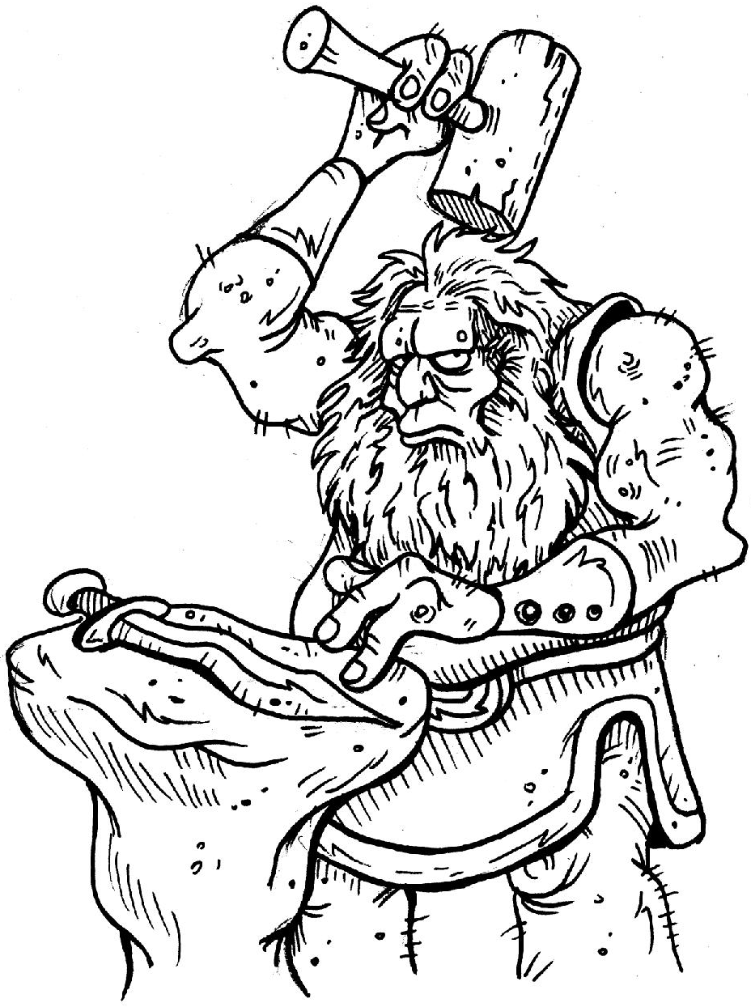
Hephaestus
Roman Name:

God of:

Parents:

Spouse:

One Fact:

Hebe
Roman Name:

Role:

Parents:

Spouse:

One Fact:

Apollo
Roman Name:

God of:

Parents:

One Fact:

Artemis
Roman Name:

Goddess of:

Parents:

One Fact:

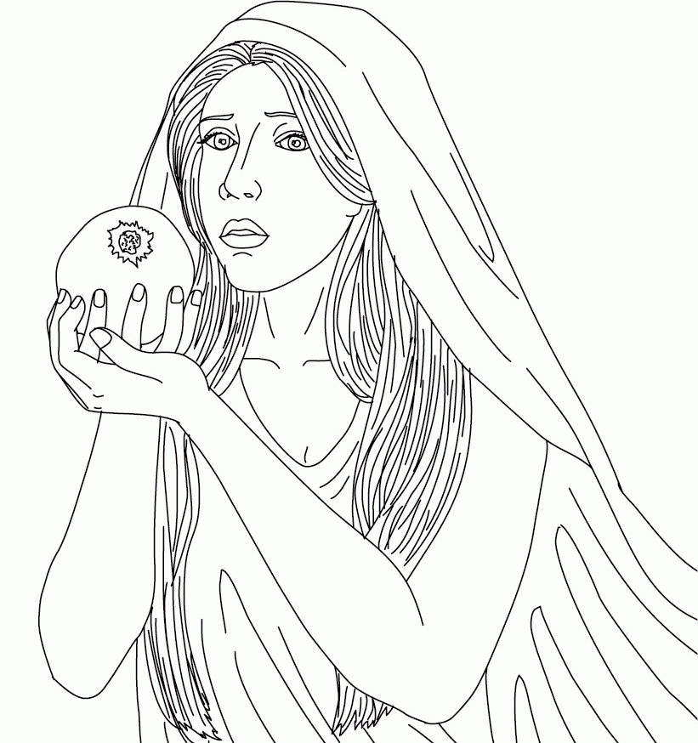

Persephone
Roman Name:

Goddess of:

Parents:

Spouse:

One Fact:

Hermes
Roman Name:

God of:

Parents:

One Fact:

Dionysus
Roman Name:

God of:

Parents:

One Fact:

Eros
Roman Name:

God of:

Parents:

One Fact:

Pan
God of:

Parents:

One Fact:

The Fates
Fate 1:

Fate 2:

Fate 3:

The Erinyes
Roman Name:

One Fact:

Chiron
What is he?

One Fact:

King Aeolus

Charybdis

Scylla

The Muses

Pegasus

Harpies

Helios

Iris
Goddess of:

One Fact:

Nymphs
What are they?

Dryads:

Naiads:

Cerberus
What is he?

Charon

