The Gods and Goddesses of Ancient Greece

Mount Olympus
What is it?
- home of the gods
- originally thought to be a real mountain

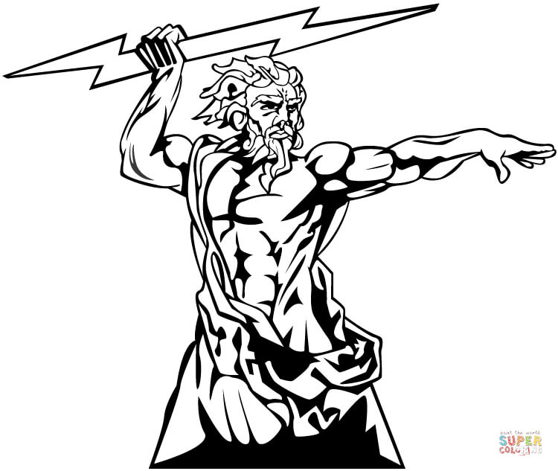
Zeus
Roman Name: Jupiter

God of: the sky/Supreme Ruler of the Gods

Parents: Chronos and Rhea

Spouse: Hera

One Fact: defeated Chronos as the previous ruler of the world

Hera
Roman Name: Juno

Goddess of: women, marriage, family, and childbirth

Parents: Chronos and Rhea

Spouse: Zeus

One Fact: very jealous of Zeus’ numerous lovers and illegitimate children and sought to torture them.

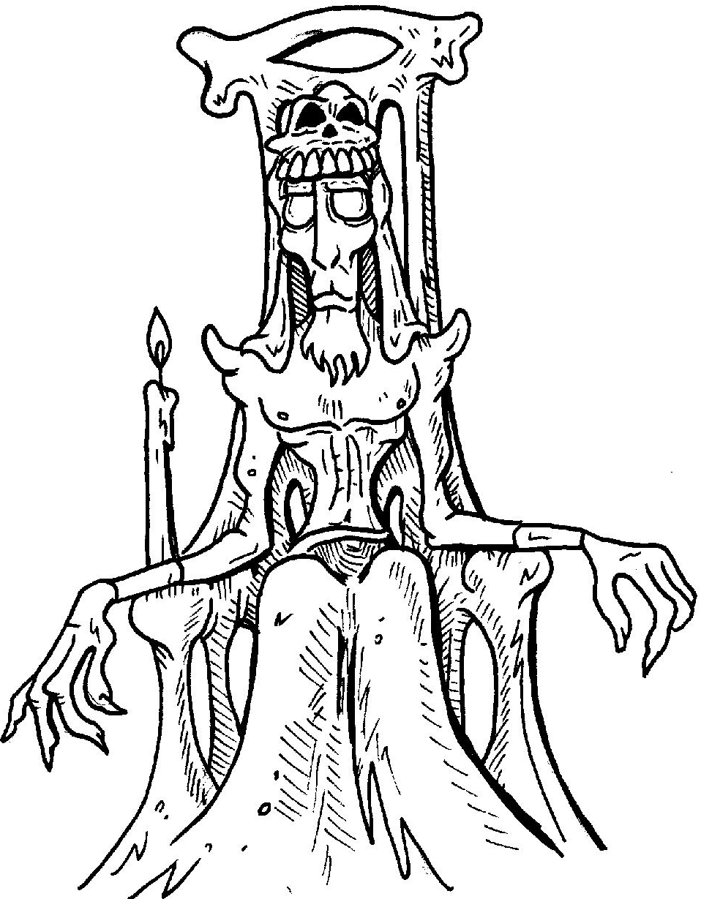
Hades
Roman Name: Pluto

God of: the Underworld/the dead

Parents: Chronos and Rhea
Spouse: Persephone

One Fact: He was the first son of Chronos and Rhea, but the last to be regurgitated, so he is considered the youngest brother.

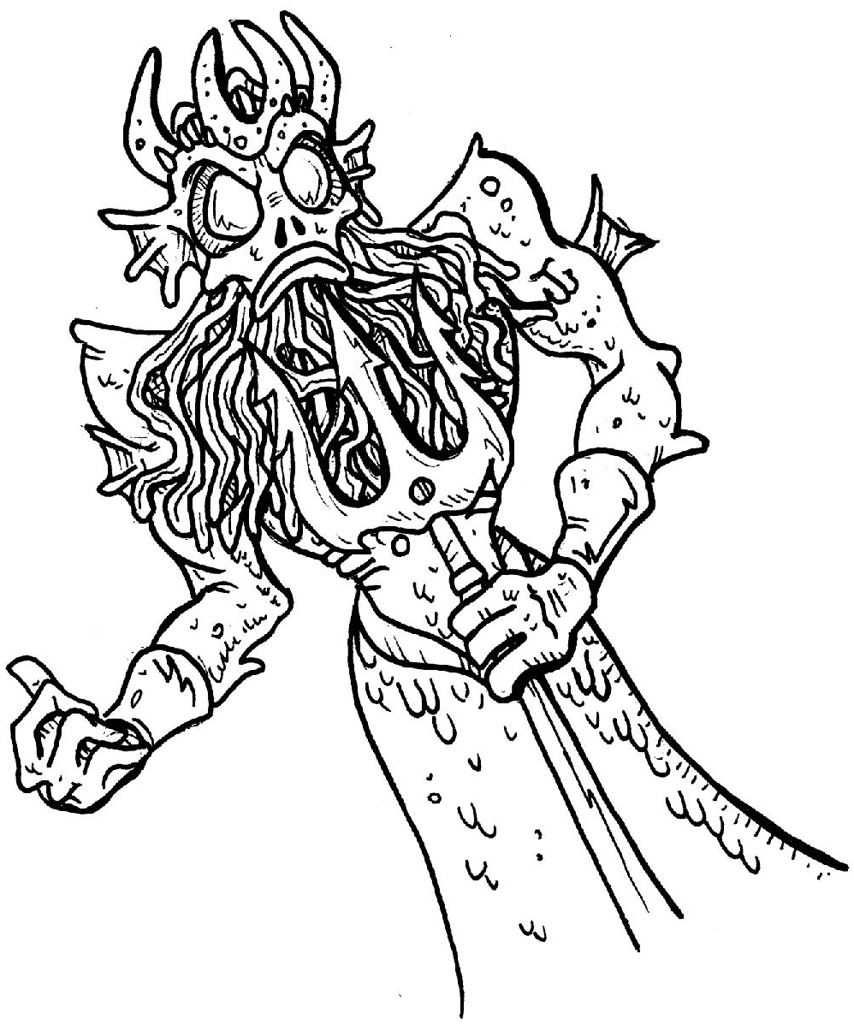
Poseidon
Roman Name: Neptune

God of: the sea, other waters, earthquakes, and of horses

Parents: Chronos and Rhea

Spouse: Amphitrite

One Fact: created horses, which is why he is the god of them

Demeter
Roman Name: Ceres

Goddess of: harvest, and agriculture

Parents: Chronos and Rhea

Spouse: n/a, but had a daughter named Persephone

One Fact: her moods affect the seasons
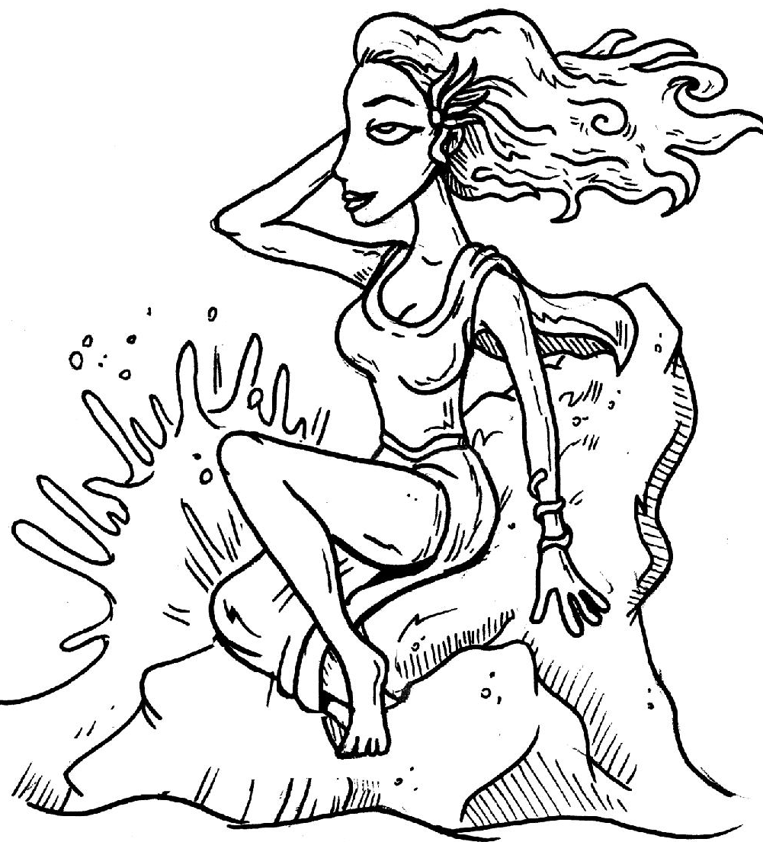
Aphrodite
Roman Name: Venus

Goddess of: love, beauty, pleasure and procreation

Spouse: Hephaestus
One Fact: her major symbols include myrtles, roses, doves, sparrows, and swans.

Hestia
Roman Name: Vesta

Goddess of: hearth, home, architecture, domesticity, the state

Parents: Chronos and Rhea

One Fact: first born daughter of Chronos and Rhea and the last to be regurgitated so was considered the youngest sister.

Ares
Roman Name: Mars

God of: war

Parents: Zeus and Hera

One Fact: none of the gods liked him very much, and Zeus even tells him that he is the god most hateful to him in The Iliad.

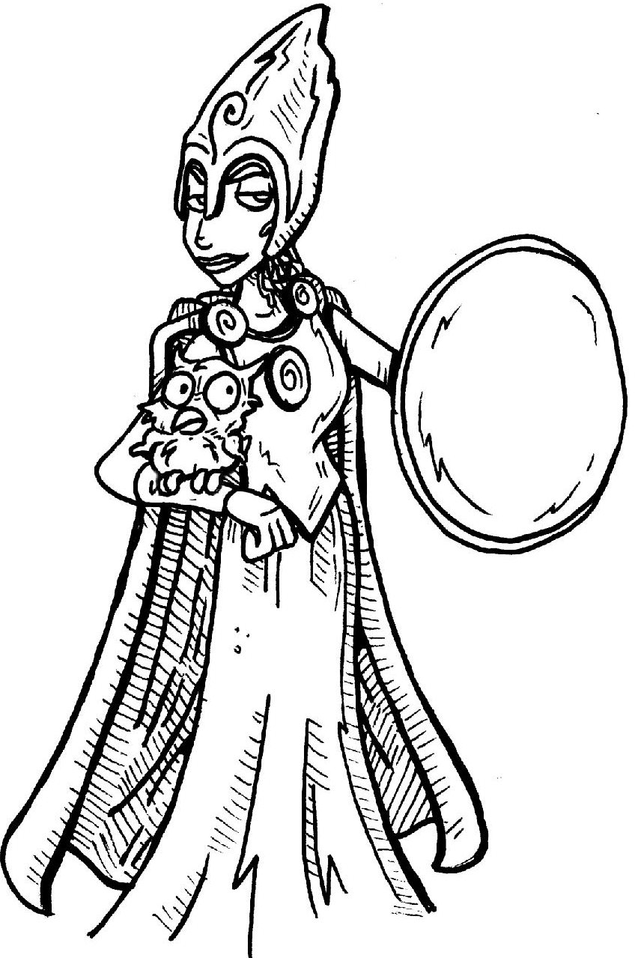
Athena
Roman Name: Minerva

Goddess of: wisdom, handicraft, and warfare

Parents: Zeus

One Fact: patron goddess of the city of Athens, winning this role in a competition with Poseidon. She created the olive tree.

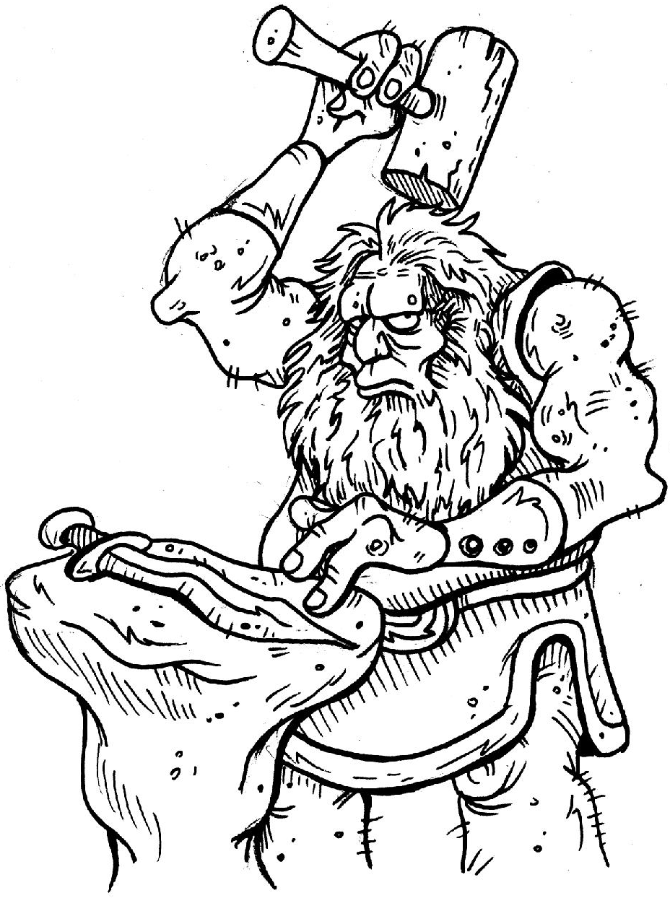
Hephaestus
Roman Name: Vulcan
God of: blacksmiths, metalworking, carpenters, craftsmen, artisans, sculptors, metallurgy, fire, volcanoes

Parents: Zeus and Hera, or just Hera

Spouse: Aphrodite

One Fact: was rejected for his ugliness and deformity and thrown off Mount Olympus and down to Earth, where he learned his craft.
Hebe
Roman Name: Juventas

Role: cupbearer to the Gods, served them nectar and ambrosia

Parents: Hera and Zeus

Spouse: Heracles

One Fact: supposed to have the power to give eternal youth

Apollo
Roman Name: Apollo

God of: music, truth, prophecy, healing, the sun, light, plague, poetry, and more
Parents: Zeus and Leto

One Fact: twin sister=Artemis, was the patron of Delphi where his oracle was quite popular

Artemis
Roman Name: Diana

Goddess of: the hunt, wild animals, wilderness, childbirth, virginity, protector of young girls
Parents: Zeus and Leto

One Fact: older twin sister to Apollo, the deer and the cypress are sacred to her

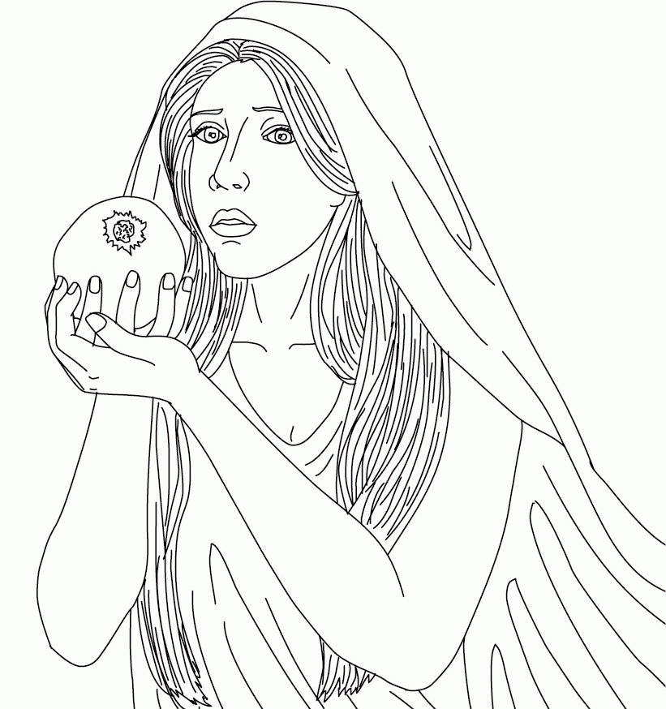

Persephone
Roman Name: Proserpine

Goddess of: spring and vegetation

Parents: Zeus and Demeter

Spouse: Hades

One Fact: Her marriage to Hades serves as the origin story for seasons
Hermes
Roman Name: Mercury

God of: messengers, boundaries/transgression of boundaries, patron of herdsmen, thieves, graves, and heralds.
Parents: Zeus and Maia

One Fact: his main symbol is the caduceus

Dionysus
Roman Name: Bacchus

God of: vine and wine

Parents: Zeus and a mortal woman

One Fact: he is a two sided god: gentle planter vs violent partier

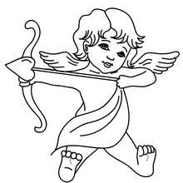
Eros
Roman Name: Cupid

God of: love, passion, and fertility

Parents: Aphrodite (dad was either Zeus, Ares, or Hermes)

One Fact: had arrows that made people fall in love

Pan
God of: woodlands and shepherds

Parents: Hermes and a nymph

One Fact: plays reed pipes made from a transformed nymph he once loved

The Fates
Fate 1: spins the thread of life

Fate 2: measures out its length

Fate 3: cuts the thread loose

The Erinyes
Roman Name: the Furies

One Fact: job is to torment people who murder a family member

Chiron
What is he? A centaur

One Fact: trained many Greek heroes.

King Aeolus

Lord of the winds

Charybdis
Gigantic whirlpool that sucks ships down to their doom

Scylla
A many headed monster that lives attached to a rock in the middle of the ocean

The Muses

Nine eternal creatures that inspire every form of art

Pegasus
Winged horse that sprang from the blood of Medusa

Harpies
Beasts with the head of a woman and the body of a bird

Helios
God of the sun, drives his glowing chariot across the sky every day

Iris
Goddess of: the rainbow

One Fact: the secondary messenger of the gods

Nymphs
What are they? Spirits of nature

Dryads: tree spirits

Naiads: spirits of the rivers and oceans

Cerberus
What is he?
Three headed hell hound of the underworld

Charon
Aged boatman of the underworld, took money to ferry souls across

