Unit 5 – The Business Plan Basics

Business Statistics
- A third of small businesses open with less than $5,000. 58% started with less than $25,000.
- Startup failure for small businesses is at 44%.
- Main reasons for failure:
  - Lack of market needs, lack of cash, hired wrong team, competitors took them out, and lack of business model.
- Most of these mistakes could have been prevented using a properly written business plan.

The Business Plan
- Once you have decided on a business it is time to make a business plan.
- Every business needs to have a professionally written business plan because it is the foundation of your business.
- A business plan is a document stating a business's future objectives and strategies for achieving them. It describes all the steps necessary for opening and operating a successful business.

Why Write a Business Plan?
- Helps the business start organized, with a common vision and mission.
- Helps attract possible investors or partners that can provide funding.
- Keeps the business moving in a positive direction.
- The business plan helps guide you through each stage of your business and helps you manage it with ease.

Purposes of a Business Plan
- It explains the idea behind your business and spells out how your product or service will be produced and sold.
- Sets specific objectives and describes how your business expects to achieve them.
- Describes the backgrounds and experience of the leadership team.

Importance of a Business Plan
- Business plans are documents used for planning out specific details about your business.
- A business plan makes you think about all aspects of your business.
- It may help you secure financing for your business.
- It helps you communicate your ideas to others.
- A business plan can serve as a tool for managing your business.

Researching
- To create a professional business plan, you will need to do an extensive amount of research.
- You must research all areas of your business, this will allow you to know all the ins and outs of your business.
- Listed below are great ways to collect research.
  - Online Resources
    - Internet, business websites, government sites, competition websites, etc.
  - In Person
    - Go into physical locations to shop, research, and observe.
  - Paper Resources
    - Public library, government documents, magazines, etc.

Business Plan Description
- Describes the nature, visions, goals, objectives, etc. of your business.
- Tells who will run and supply your business.
- Explains how your business will win over customers and beat competition.
- Provides detailed financial information on how your business will make a profit.
- Describes plans for future growth.

Steps to Creating a Business Plan
- Pick a business plan format that works for your business.
- Types of business plans:
  - Traditional- uses a standard structure and encourages you to go into great detail for each section.
  - Lean Startup- uses a standard structure but focuses on summarizing the key points and elements of the business.
- Use a business plan template to help you get started.
  - You can find these online with ease.

What’s Included on a Business Plan?
- Business plans can be daunting to complete but remember it is an important part to starting up your business.
- There are 7 sections to a professional business plan.
  - Executive Summary
  - Business Description
  - Product and Services
  - Market Analysis & Marketing Plan
  - Operations Overview
  - Financial Plan
  - Appendix

Executive Summary
- This is the portion of the plan that summarizes your company. It can include an overview of your company's management structure, a description of your product/service, your goals, and a summary of your finances and marketing strategy. Think of it as everything you would say about your company in a five-minute interview.
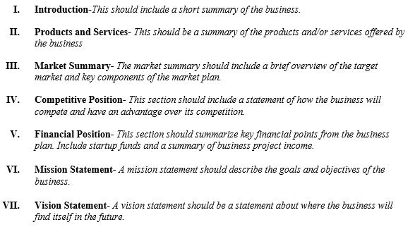

Business Description
- This is a brief rundown of your business's history, ownership, and mission or vision statement.

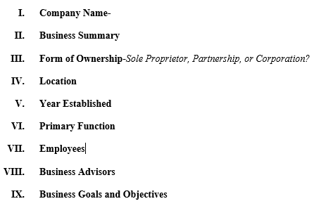

Product or Services
- This section includes a breakdown of what your product or service is, its unique features, any patents you may have, as well as any future products you want to develop.
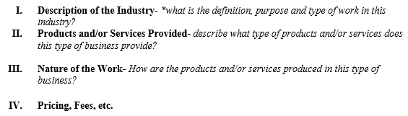

Marketing Analysis and Marketing Plan
- This section includes an actual assessment of the target population, competition, and needs for marketing a product or service.
- In this section, you will also include your ideas for promotion (online/traditional methods), as well as how you physically plan to sell your product or service (brick-and-mortar, e-commerce, etc.).
- Describe your products or services and explain how they differ from those already on the market.
- Explain who your prospective customers are, how large the market is, how you plan to enter the market, and deal with the competition.
- Describe the industry in which you will operate.
- Explain the location of your business.

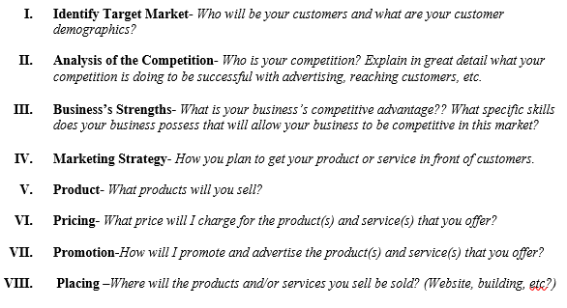

Operations
- An operations overview provides a glimpse into the daily operations of your business, including the management and staffing structure, human resources plan, your physical operational facility, and your production methods, such as quotas or manufacturing details.
- Explain how the business will be managed on a day-to-day basis, and discuss hiring and personnel procedures.
- Include information on insurance, and lease/rental agreements.
- What equipment will be needed for the production of your product or service?
- Include an exit strategy, which is the way an entrepreneur intends to extract, or harvest, their money from a business after it is operating successfully.

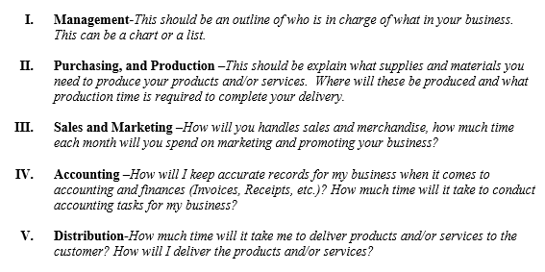

Financial Management
- Your financial plan may include your company's income (profit and loss) statements.
- It can also encompass your capital requirements if you are pitching your ideas to investors.
- In that case, you may describe the investment amount you require and how you plan to repay this capital in a repayment plan.
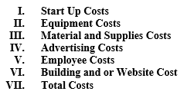

- Identify any risk your business may face and how you plan to deal with it.
- Include projected financial statements.
- Indicate how much you need to borrow and how you plan to use the money.

Appendix
- This section should include all the attachments needed:
  - Advertisements
  - Pictures of your business location and products
  - Business Logo
  - Any other documents needed to show your full business plan.

Introduction
- At the beginning of your business plan you can include a detailed description of the nature of the business and its goals.
- It can also cover the ownership of the business and the legal structure, the skills and experience you bring, and the advantages your business has over the competition.

Concluding Statement
- At the end of your business plan, you can add a concluding statement that emphasizes your commitment to the success of the business. This a great time to truly sell yourself.
- The concluding statement should also summarize the goals and objectives you have for your business.

Finalizing Your Business Plan
Include:
- All business plans need to include the following to make it professional:
  - Cover Letter
  - Title Page
  - Table of Contents
  - Statement of Purpose

Don’t Forget!
- Once you have created your business plan be sure to proofread and make it PERFECT!

Mistakes in Business Planning
- Unrealistic financial projections
- An undefined target market
- Poor research
- Ignored competition
- Inconsistencies in the business plan.
- The people who are considering investing don’t understand your vision or think it’s profitable.

Business Plan Tips
- Know your competition and audience.
- Have proof of all claims.
- Be realistic with time and resources available.
- Have a strong team.
- Document how your idea will work.
- Be logical.
- Describe your facilities and location for performing the work.

