You + The Media Name: _______________________
Fill in each square with your likes/dislikes. | Likes: -Yes!  -Favourite!  -Love it! | 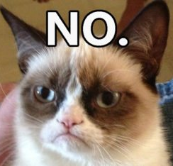  Dislikes: -No  -Hate it  -The Worst
Song (or album, or band/artist)

Radio Station, Radio Show, or Podcast

TV Series

Movie

News, or place to get news, or magazine

App

Game (board or video)

Candy

Drink

Snack

Restaurant

Store (or brand)

Commercial or Advertisement

Gadget (or electronic device)

Technology (existing or fictional)

Social Media

Website

Meme

Thing

I am/Not Poem Name: _______________________
Choose 15 (or more) items from your You + The Media brainstorm sheet. Use these (or other information about yourself) to create a one of a kind poem about yourself. For positive items, you might start with “I am…” while for negative items, you might use “I am not…” Of course, you can be creative and write your poem any way you like as long as it is 15 lines long. The poem does not have to rhyme. The last line of your poem should be your name.

1.

2.

3.

4.

5.

6.

7.

8.

9.

10.

11.

12.

13.

14.

15.

I am _________________________________________________________________________
(Poet’s Name)

